Data Import & Transformation

1. Data Import:

○ Import List of Orders.csv into Power BI.

○ Open the list of orders in the Power Query Editor using the Transform Data option.

○ Import Order Details.csv and Sales Target.csv into Power Query Editor.

Steps :
- Open Power BI Desktop.
- Click the Home tab.
- Click Get Data.
- Select Text/CSV.
- Browse and select List of Orders.csv.
- Click Open.
- Preview the data.
- Click Transform Data if you want to clean the data.
- Click Close & Apply in Power Query Editor.
- Wait for the data to load.

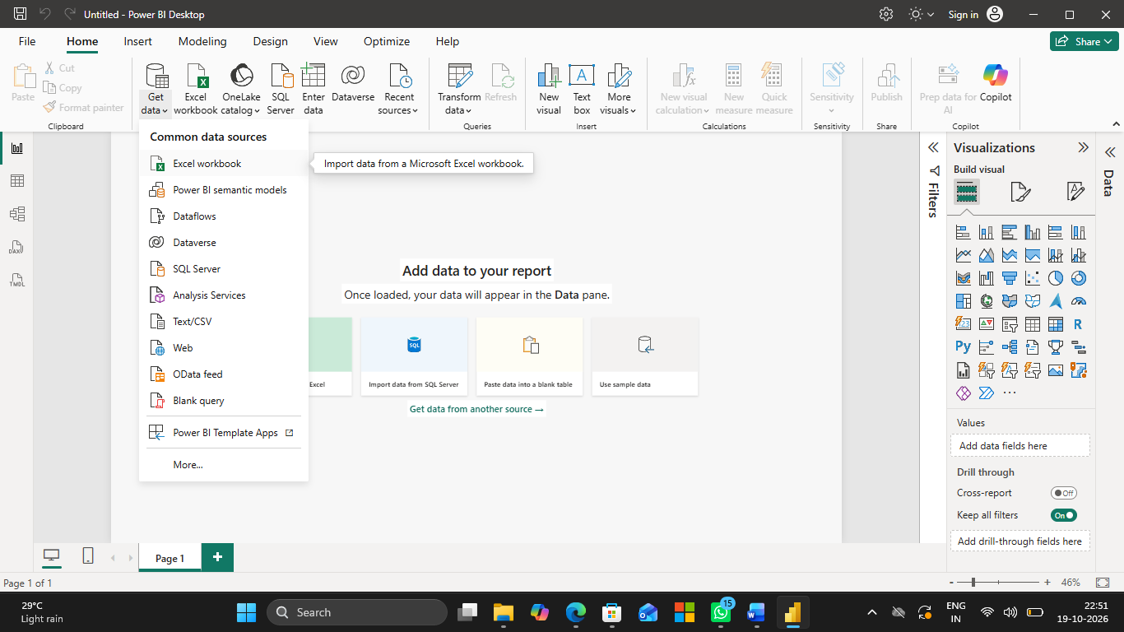

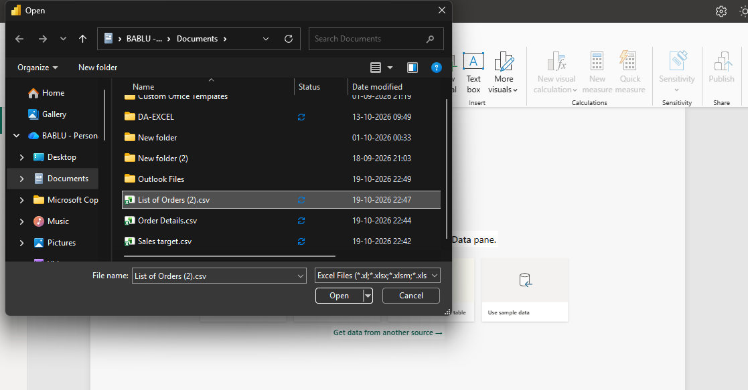

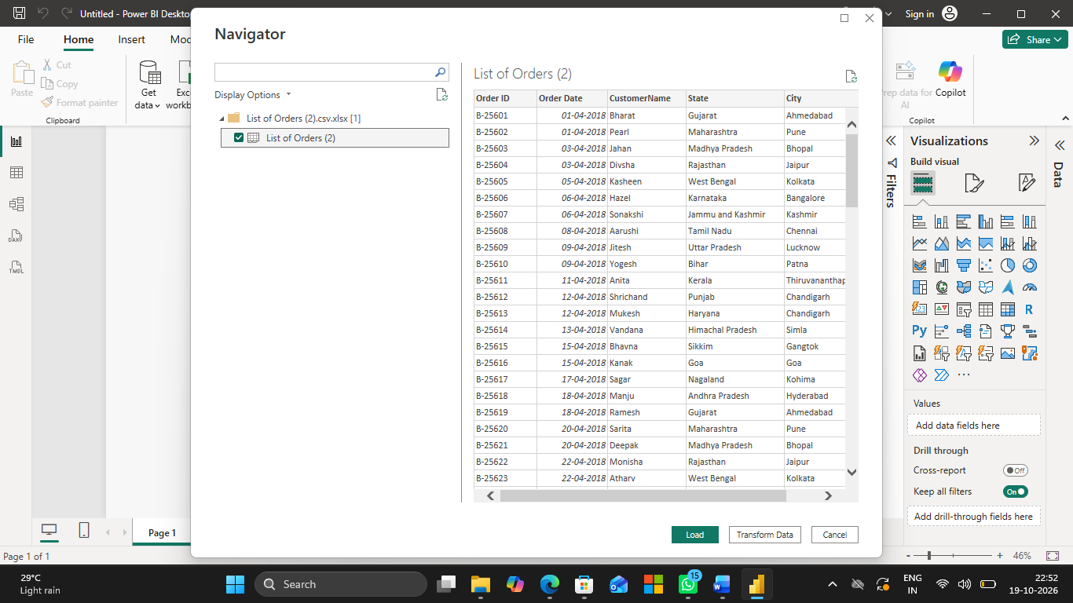

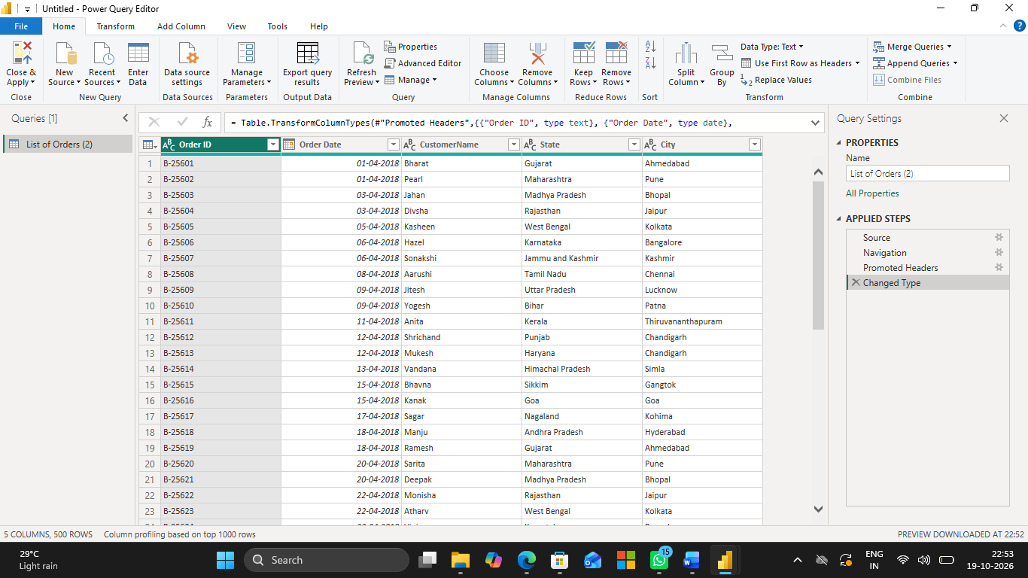

Final Result:

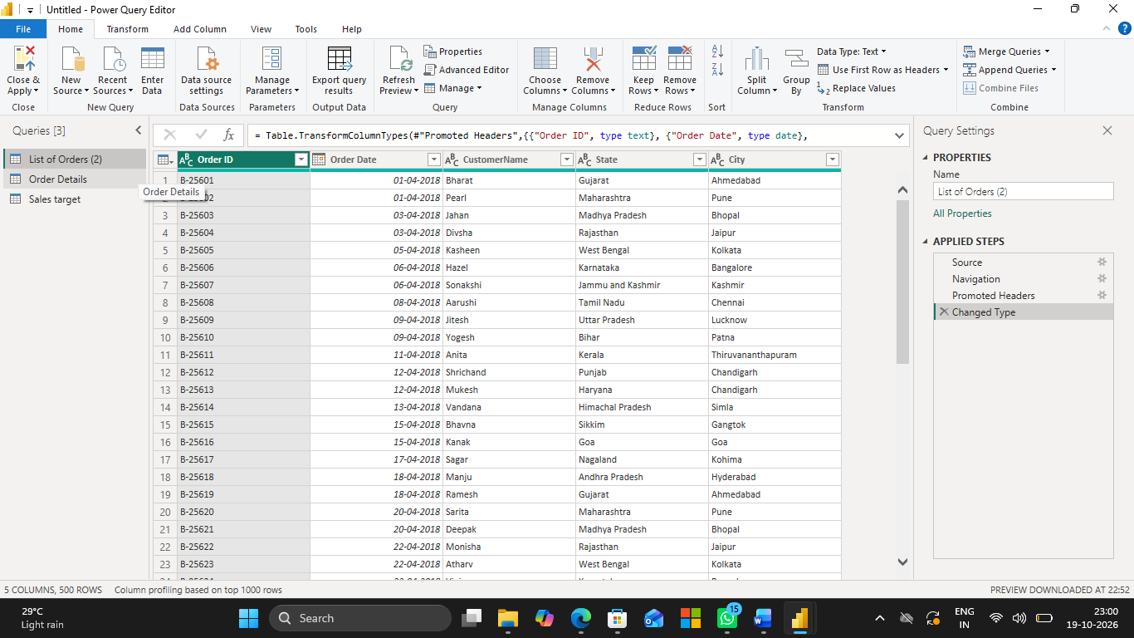

2. Row Limiting & Data Types:

○ Restrict the List of Orders table to the first 500 rows.

Steps:
- Open Power Query Editor.
- Select the List of Orders table.
- Go to the Home tab → Keep Rows → Keep Top Rows.
- Enter 500 and click OK.

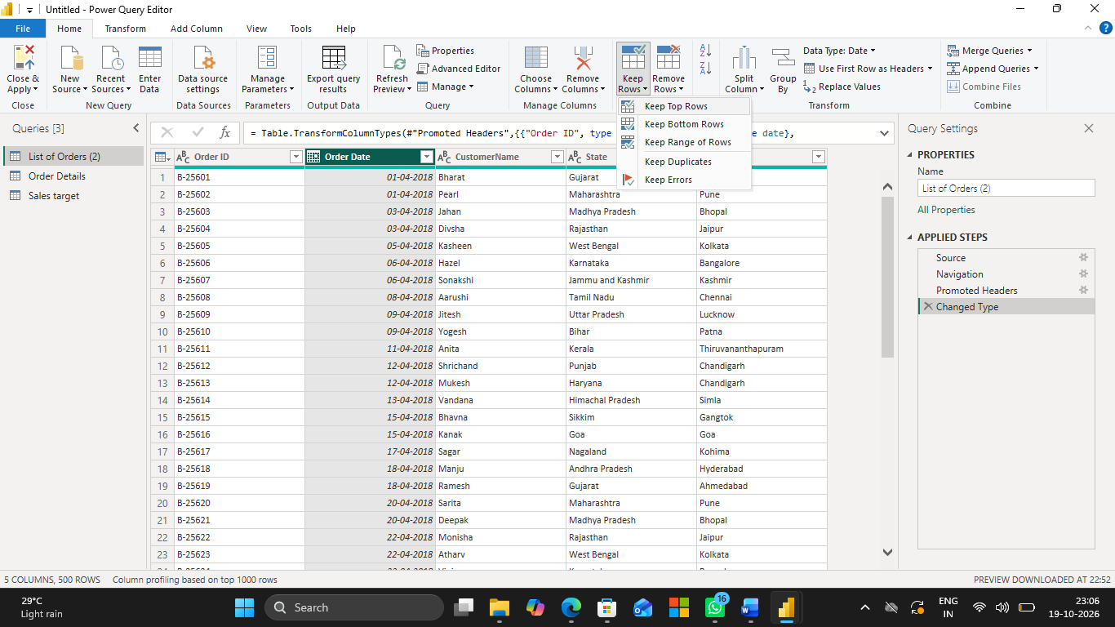

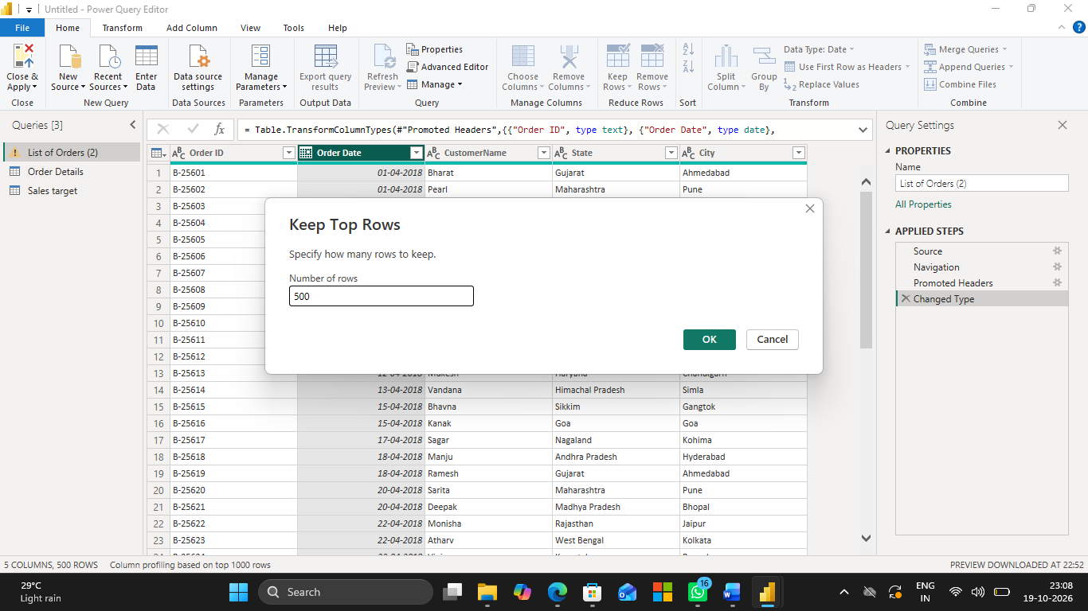

Final result:

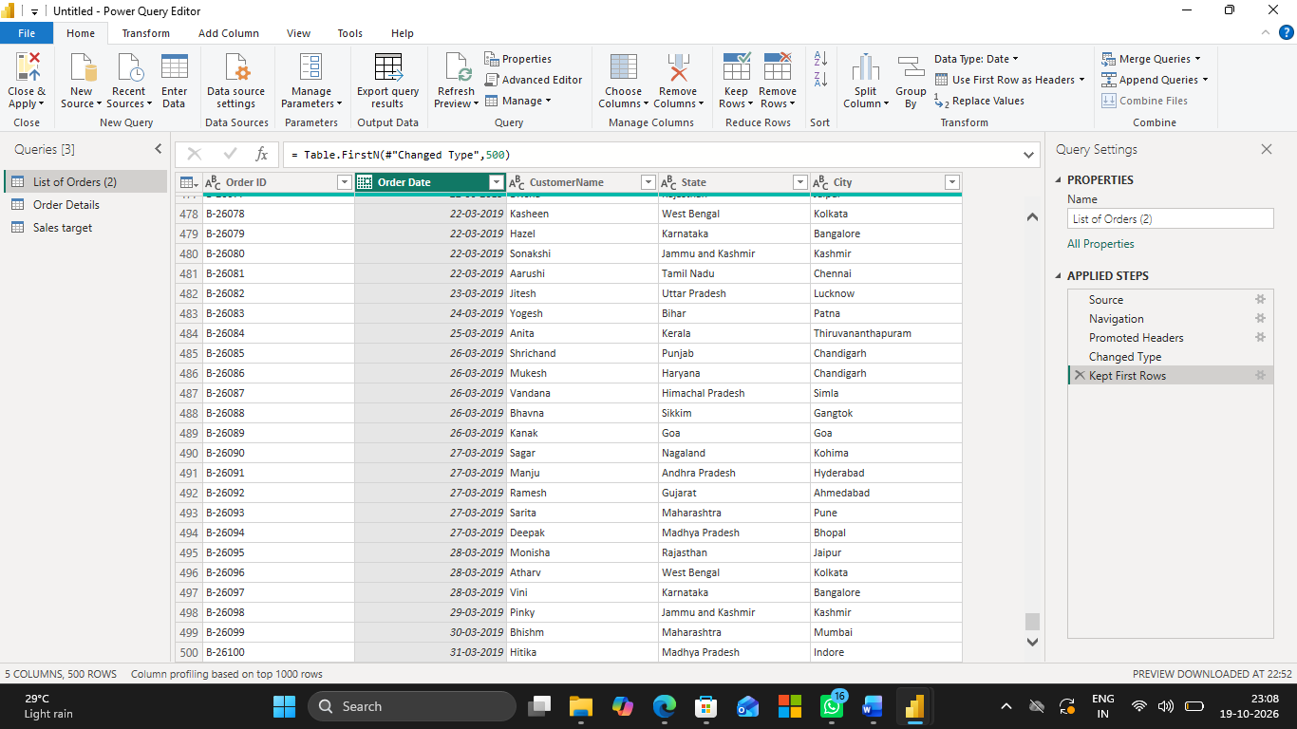

○ Set the Order Date column to the Date data type.
- Select the Order Date column.
- Go to Transform → Data Type → Date.

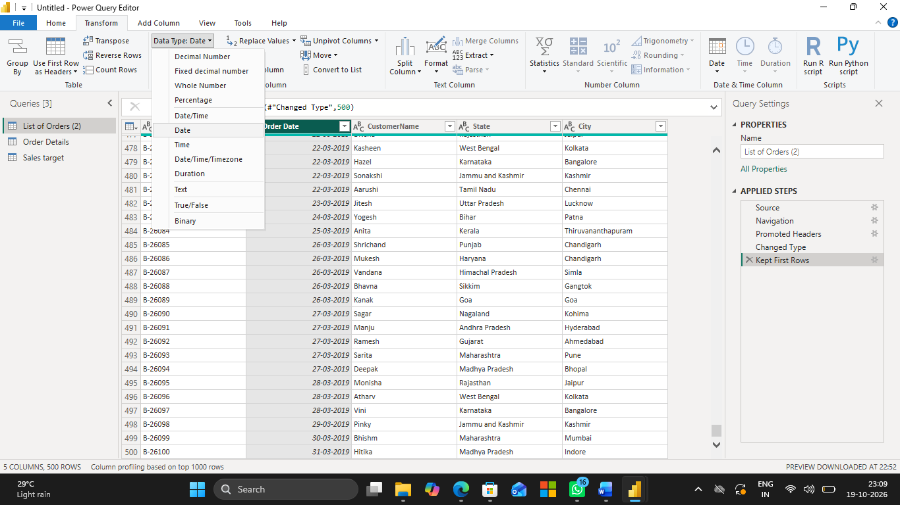

Final result:

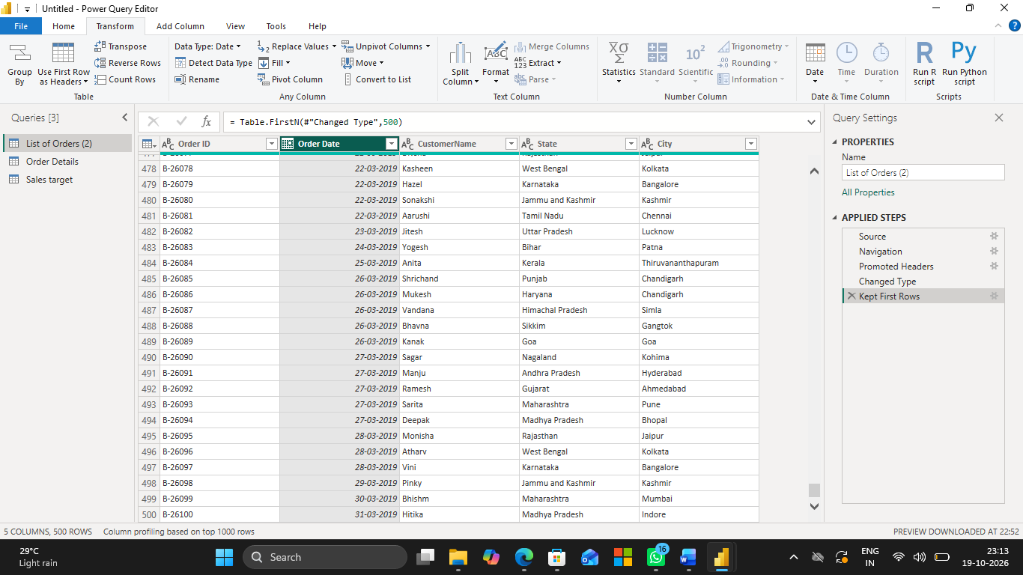

○ Change the Amount and Target columns to fixed decimal numbers.

- Select the Amount column.
- Go to Transform → Data Type → Fixed Decimal Number.

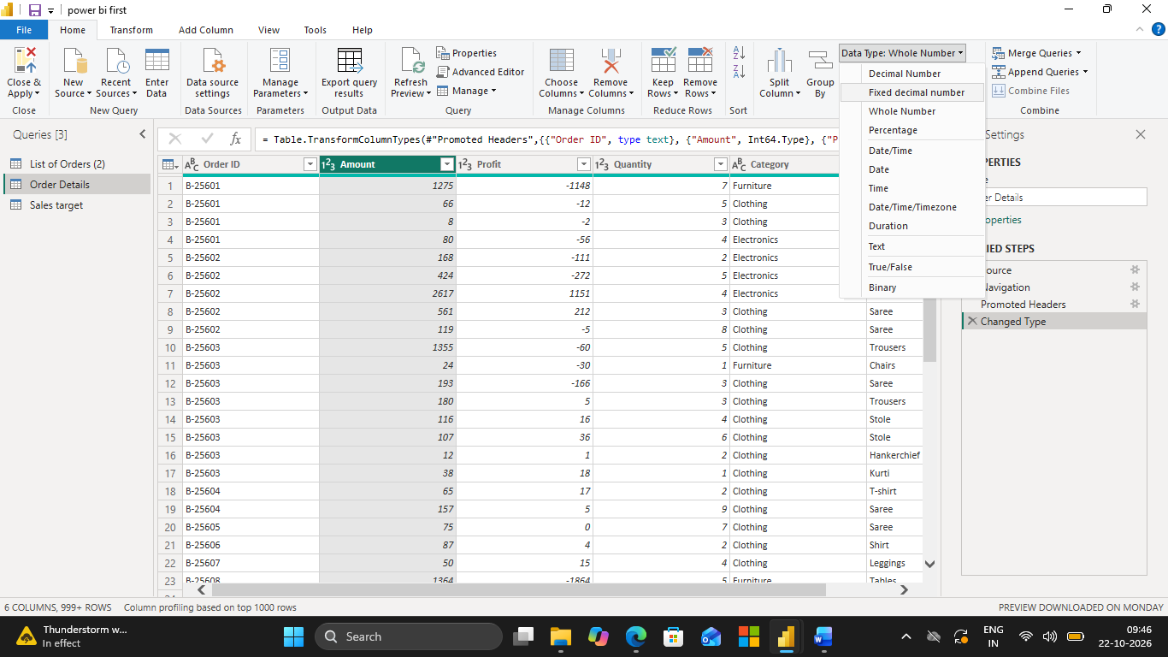

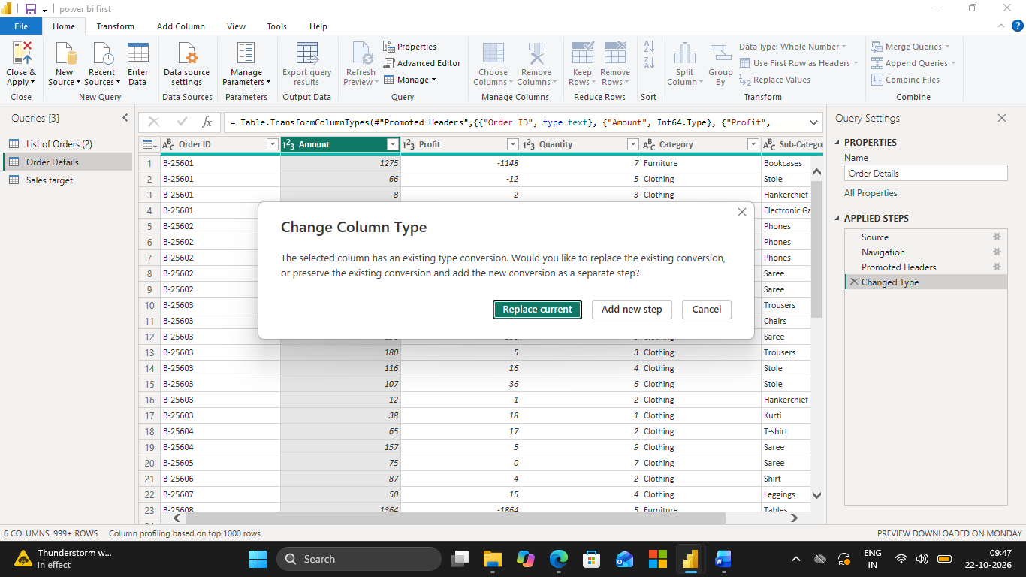

Final output:

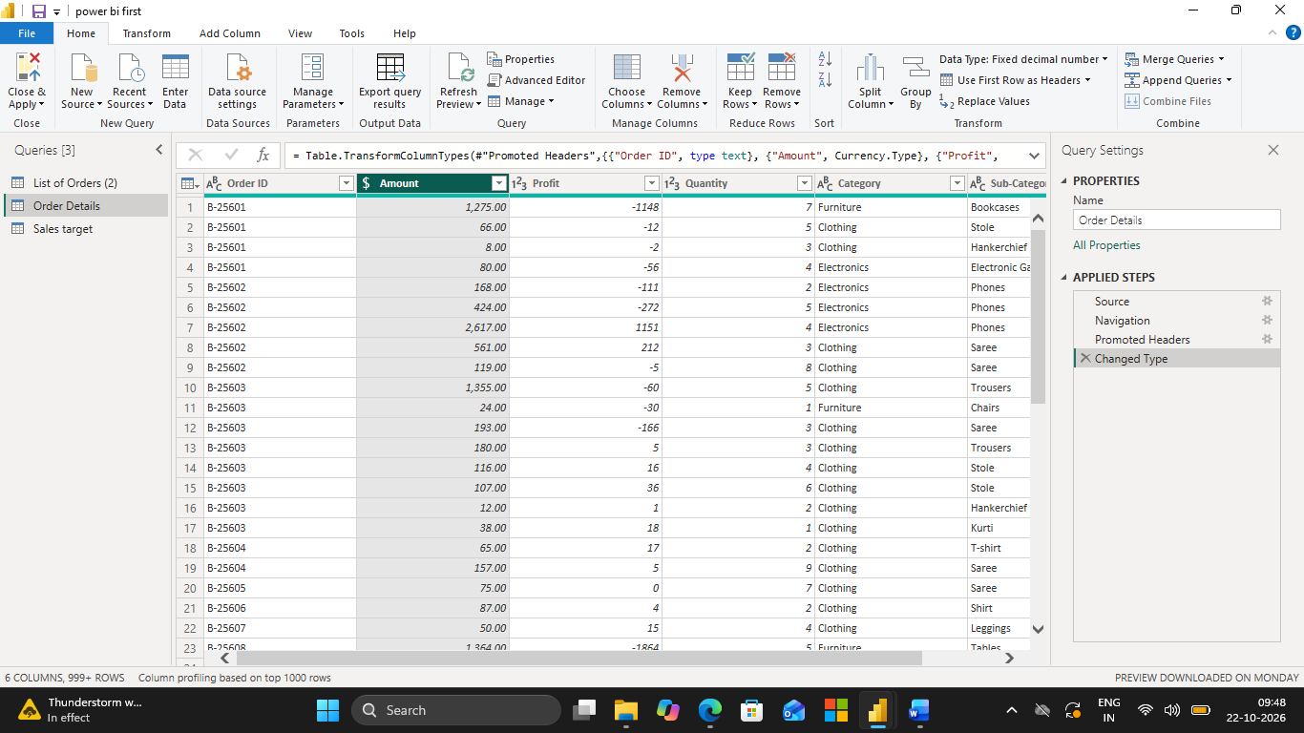

- Select the Target column.
- Go to Transform → Data Type → Fixed Decimal Number.
- Click Close & Apply.

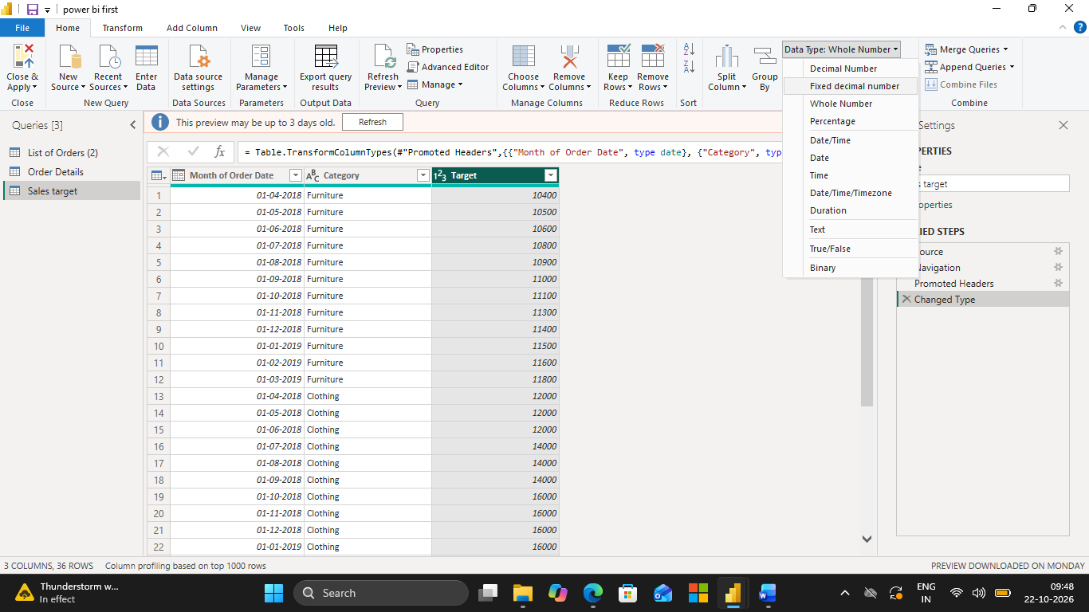

Final output;

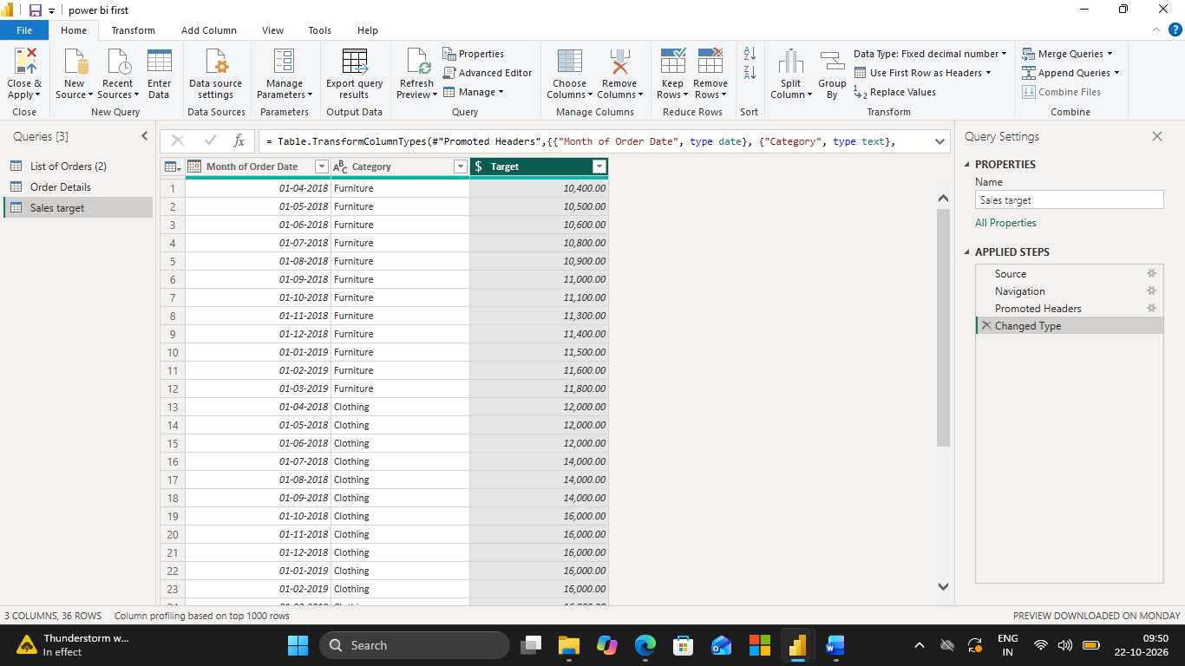

3. Text Formatting:

○ Format the CustomerName column to proper case to ensure consistent capitalization.

Steps:
- Click Transform Data.
- Select the CustomerName column.
- Go to the Transform tab.
- Click Format → Capitalize Each Word.
- Check that the names have consistent capitalization.
- Click Close & Apply.

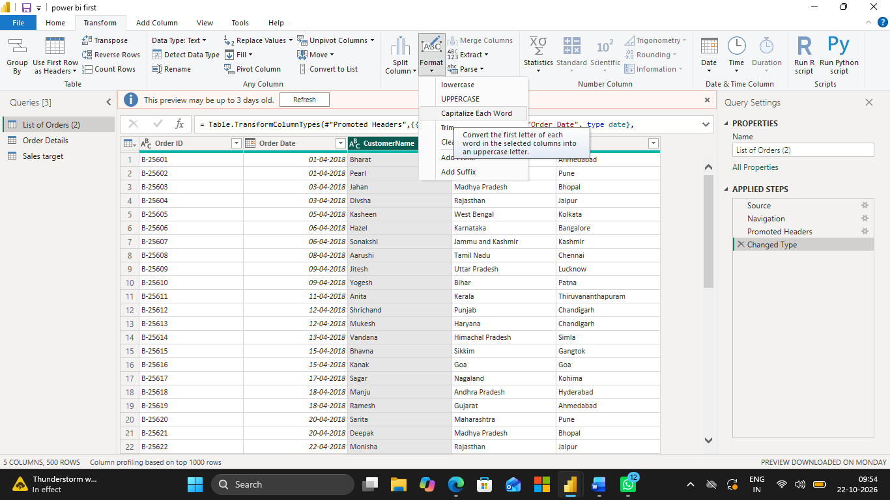

Final output:

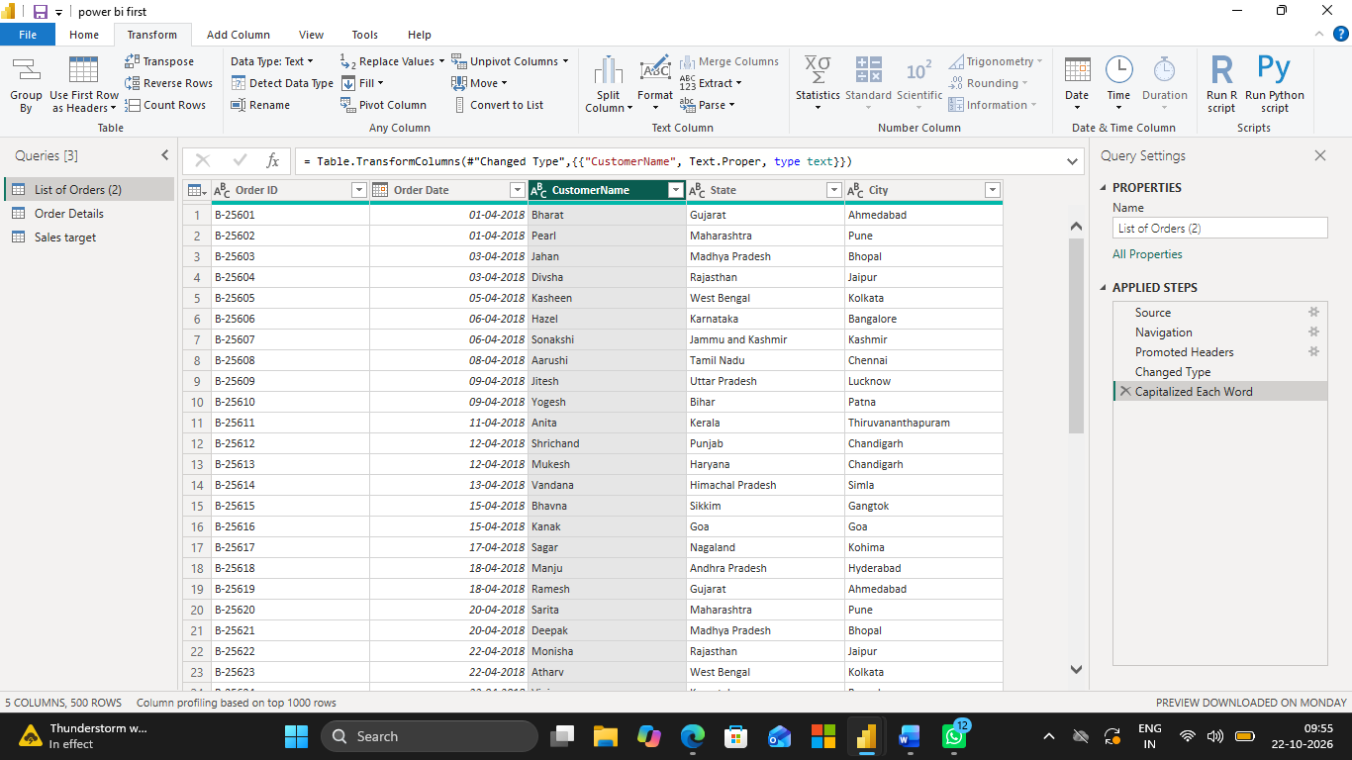

4. Column Creation:

○ Merge the City and State columns to create a new column named Location in the format: City, State.

- Click Transform Data.
- Select the City column.
- Hold Shift and select the State column.
- Go to Transform → Merge Columns.
- Select Custom as the separator and enter , .
- Enter Location as the new column name.
- Click OK.

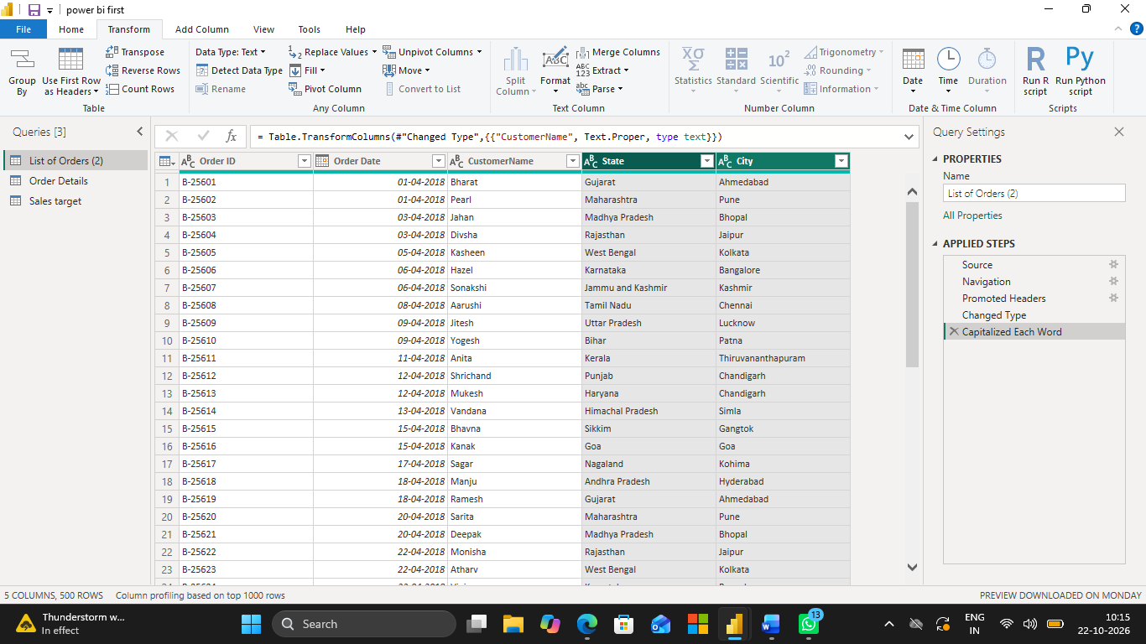

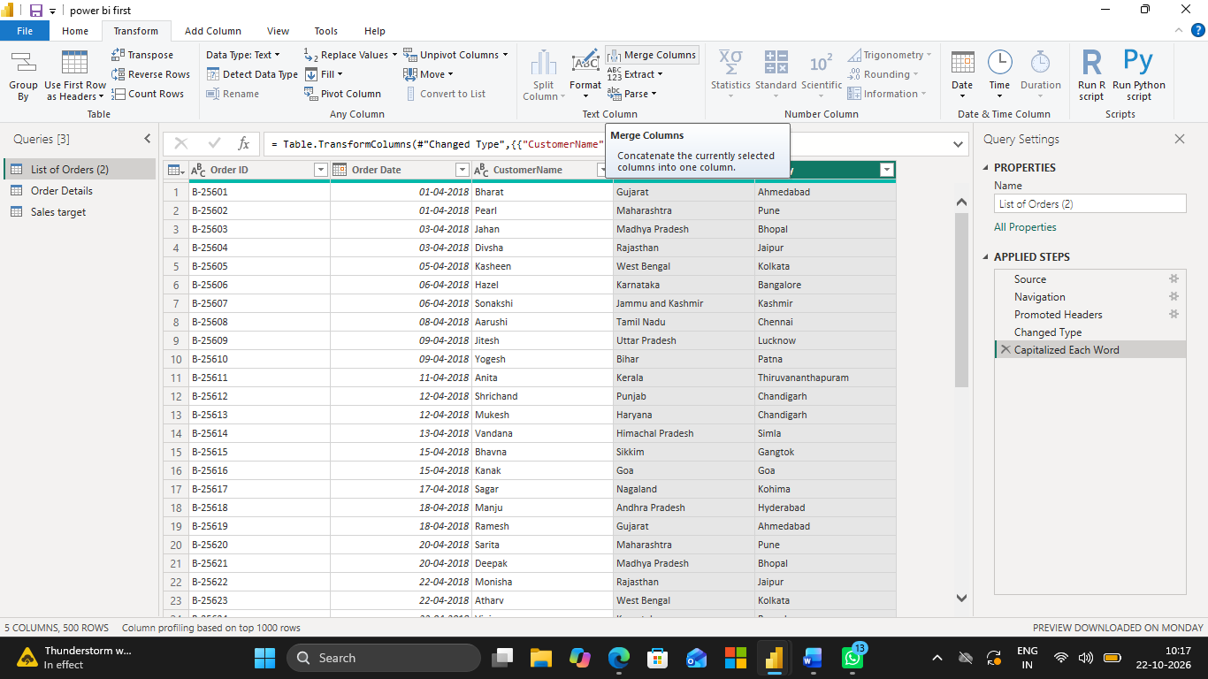

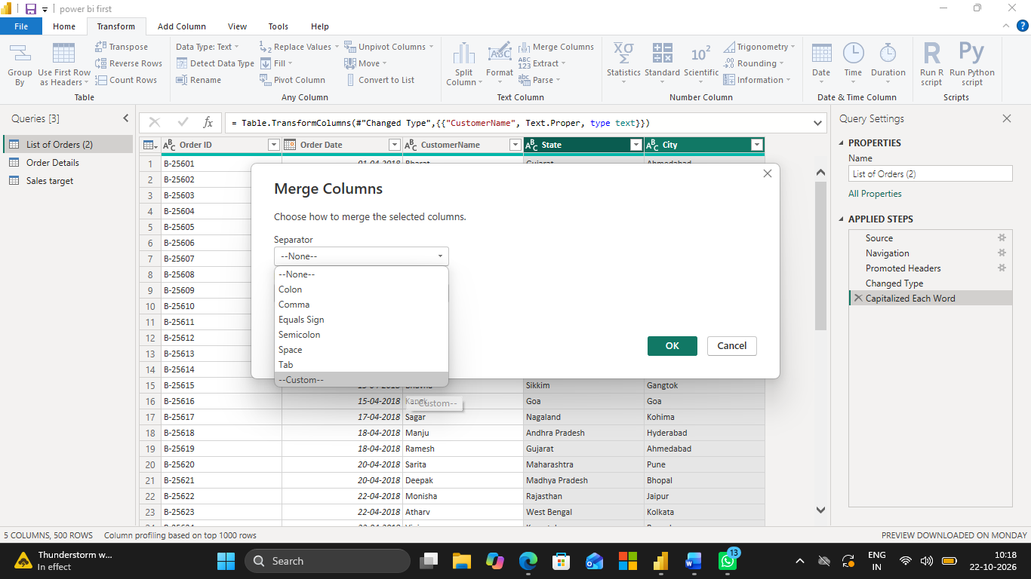

Final output:

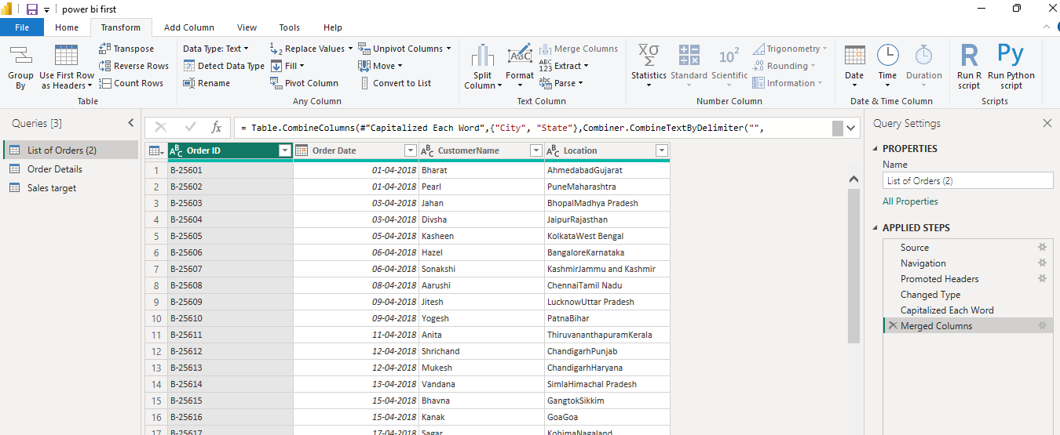

○ Create a custom column named Profit Margin calculated as: Profit / Amount (expressed as a percentage)

- Go to Add Column → Custom Column.
- Enter Profit Margin as the new column name.
- Enter this formula:

[Profit] / [Amount]
- Click OK.
- Select the Profit Margin column.
- Change its data type to Percentage.

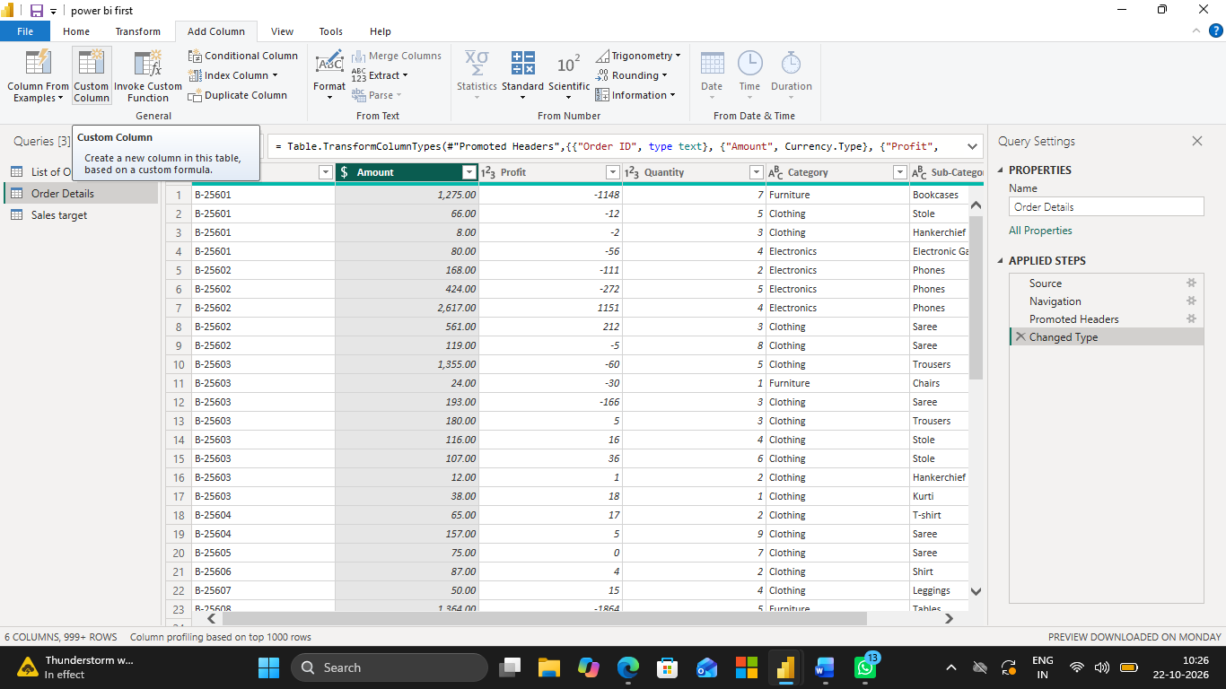

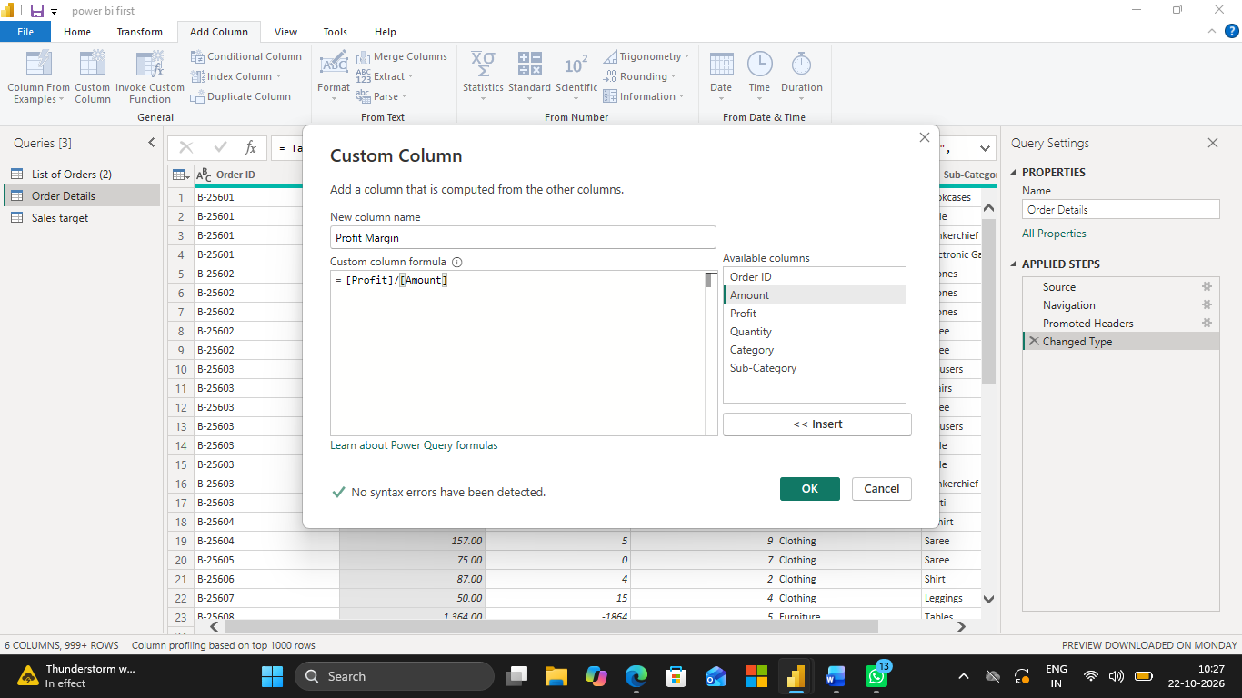

Final output:

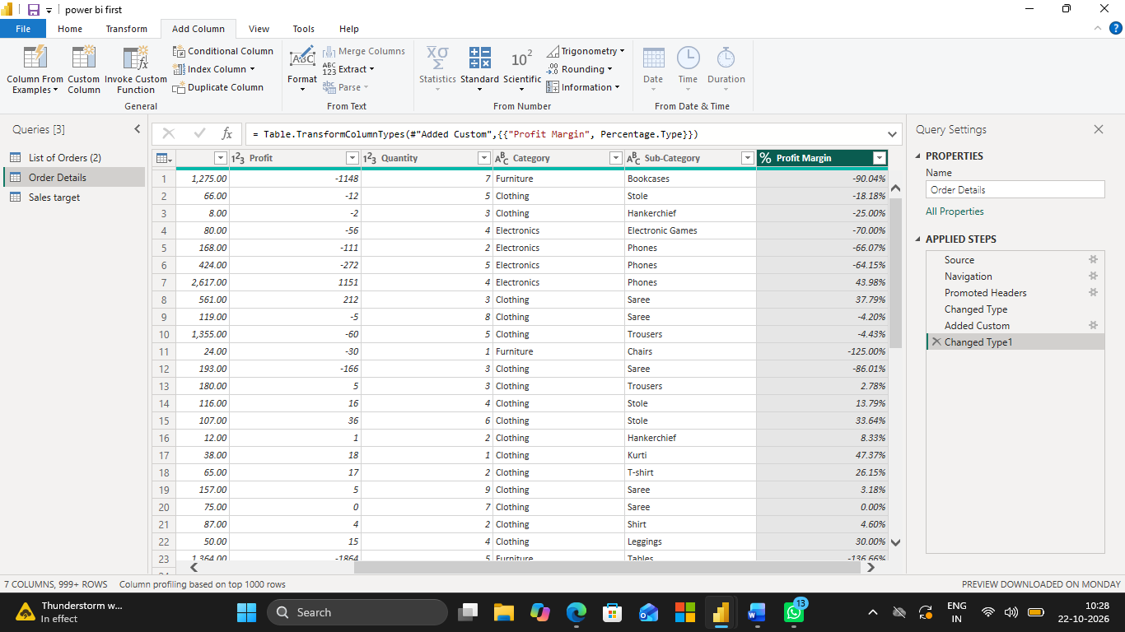

5. Conditional Column:

○ Add a conditional column named Profit Status based on:

■ Profit < 0 → Loss

■ Profit = 0 → Break-Even

■ Profit > 0 → Profit

Steps:
- Click Transform Data.
- Go to the Add Column tab.
- Click Conditional Column.
- Enter the column name: Profit Status.
- Set the first condition:
  - Column Name: Profit
  - Operator: is less than
  - Value: 0
  - Output: Loss
- Click Add Clause and set:
  - Column Name: Profit
  - Operator: equals
  - Value: 0
  - Output: Break-Even
- In Else, enter Profit.
- Click OK.

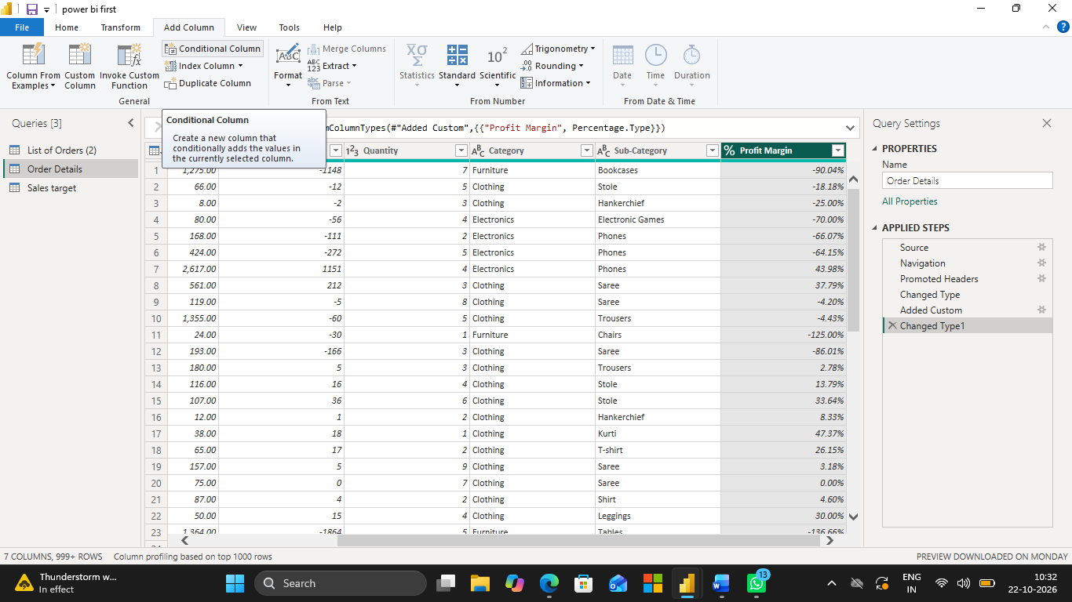

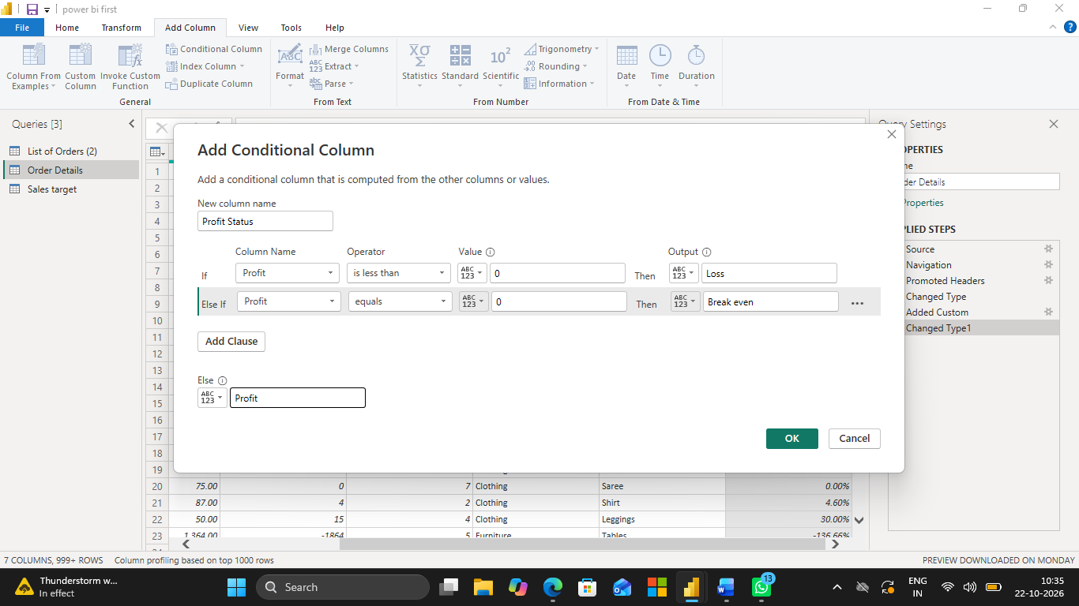

Final output:

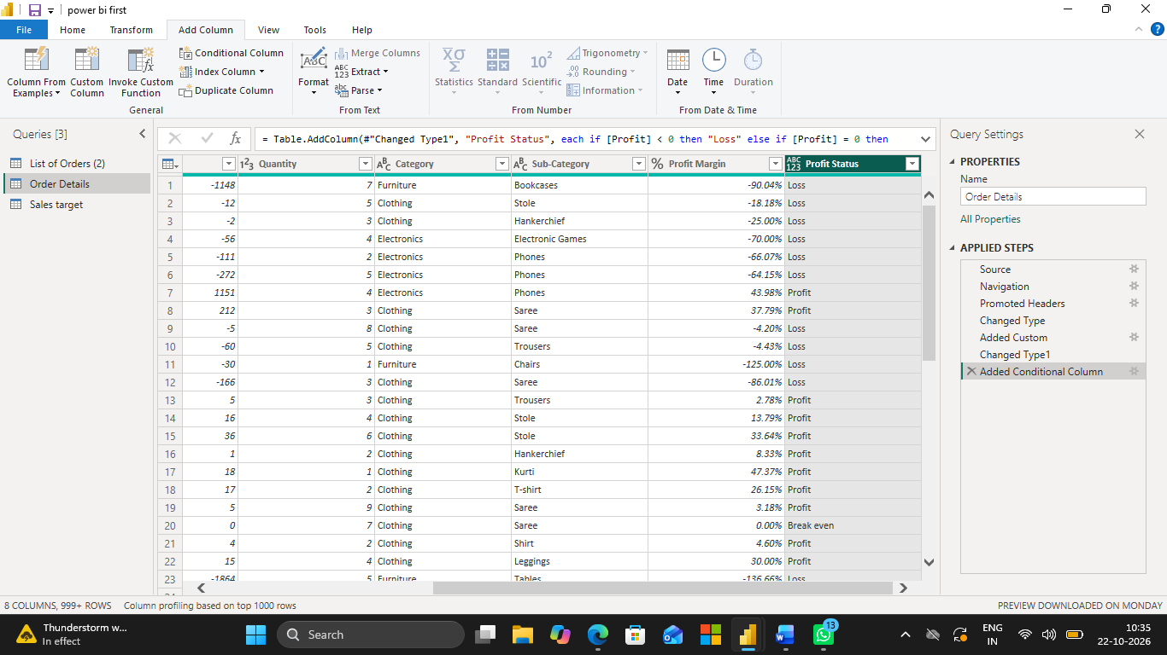

6. Merging Data (Joins)

○ Merge the List of Orders and Order Details tables using Order ID.

○ Name the merged output table as Orders Data.

Steps:

- Select the List of Orders table.
- Go to Home → Merge Queries → Merge Queries as New.
- Select Order Details as the second table.
- Click the Order ID column in both tables.
- Select Left Outer Join as the Join Kind.
- Click OK.
- Rename the new merged table to Orders Data.
- Click Close & Apply.

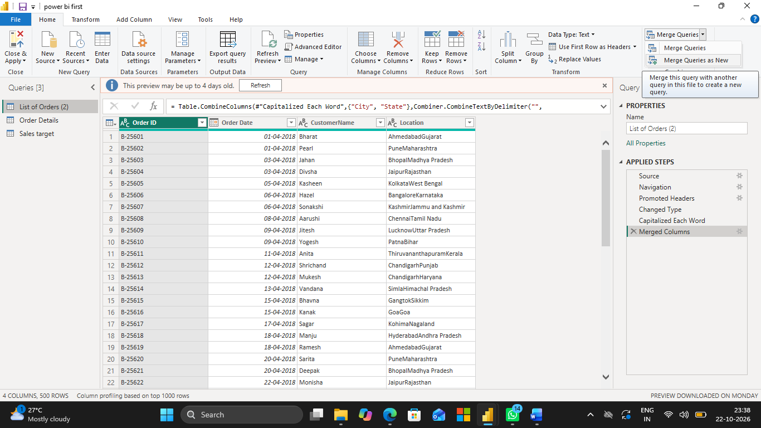

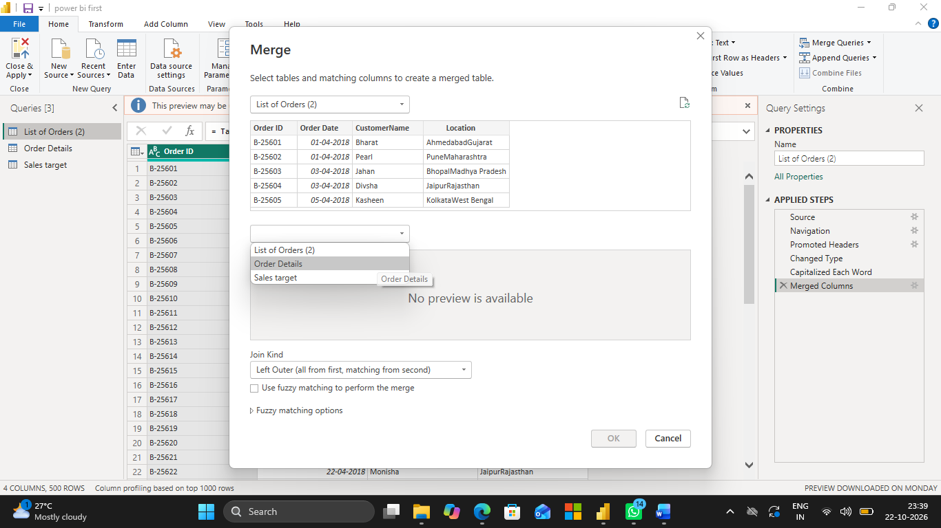

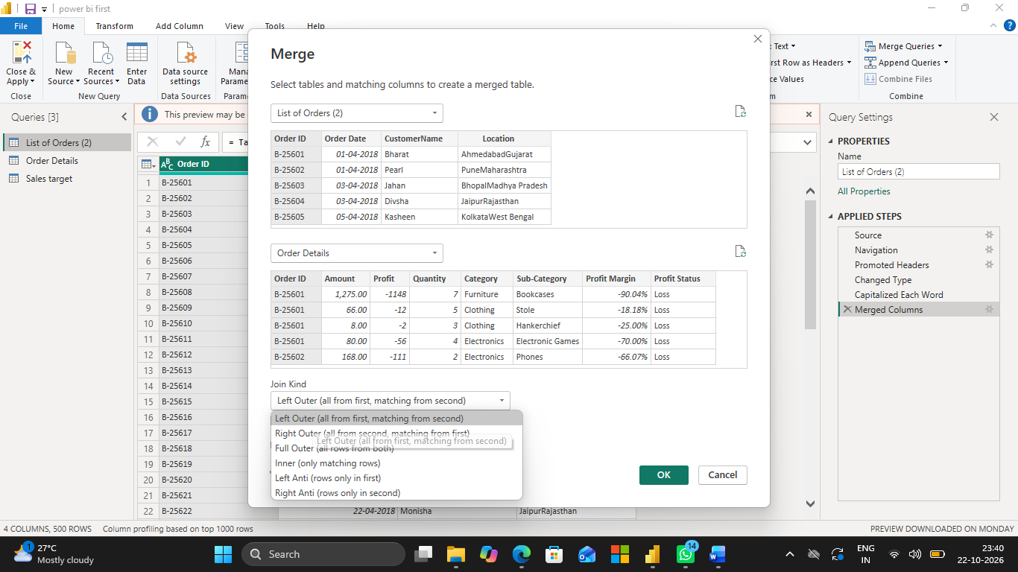

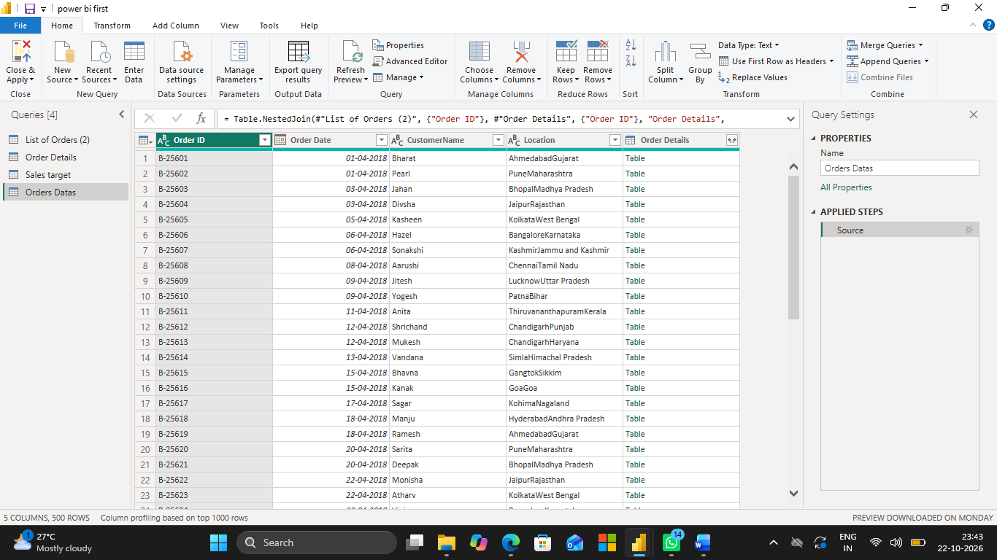

7. Handling Missing Data & Duplicate Data

● Identify missing values across all tables.

Steps
- Click Home → Transform
- Select each table one by one.
- Check all columns for blank or null values.
- Select the column containing missing values.
- Replace missing values using Transform → Replace Values, if appropriate.
- Remove records with missing values if they are unusable.
- Retain null values if the information is unknown and cannot be safely replaced.

● Define and apply appropriate strategies such as:

○ Replacing missing values

○ Removing records

○ Retaining nulls with justification

Steps to Handle Duplicate Rows
- Select the required table in Power Query Editor.
- Select the columns to check for duplicates.
- Go to Home → Remove Rows → Remove Duplicates.
- Check the data to ensure valid records are not removed.
- Repeat for other tables if necessary.
- Click Close & Apply.

● Identify duplicate rows and define a suitable handling strategy based on business logic.

- Replace missing values only when the correct value is known.
- Remove records only when they are invalid or unusable.
- Retain nulls when information is unknown.
- Remove duplicate records only when they are confirmed duplicates based on business rules.

8. Sorting and Filtering Data

● Sort records in the Orders Data table by Order Date in descending order.

Steps
- Select the Orders Data table.
- Select the Order Date column.
- Click the dropdown arrow in the column header.
- Select Sort Descending.
- The latest order dates will appear first.

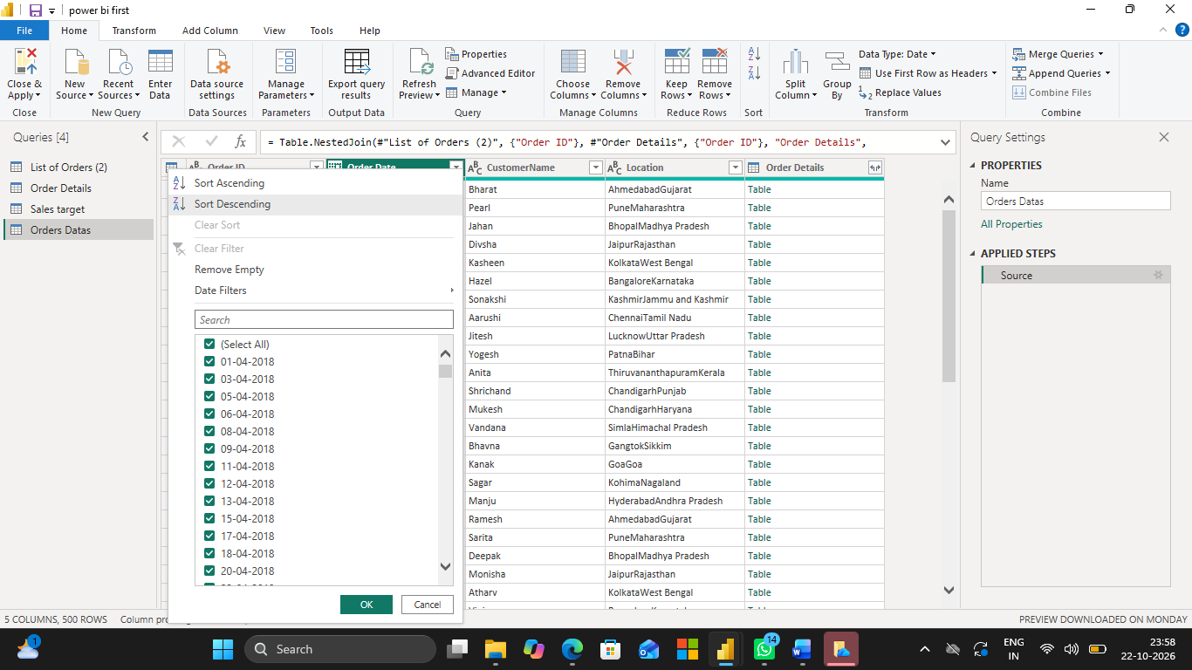

Final output:

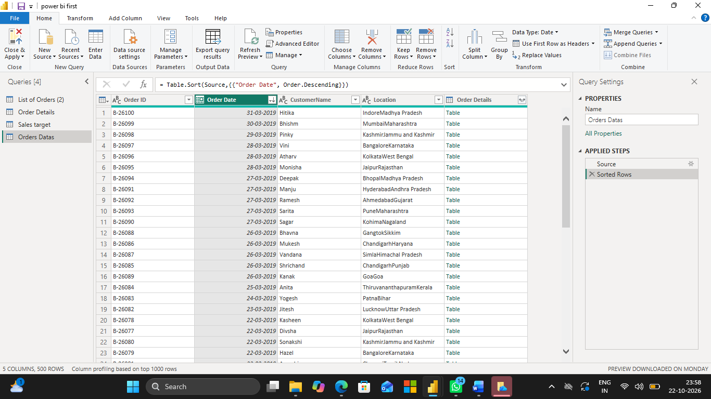

● Apply filters to analyze orders from a specific state (e.g., Tamil Nadu).

Steps
- Select the Location column.
- Click the dropdown arrow in the column header.
- Uncheck Select All.
- Select Tamil Nadu.
- Click OK.
- Only orders from Tamil Nadu will be displayed.

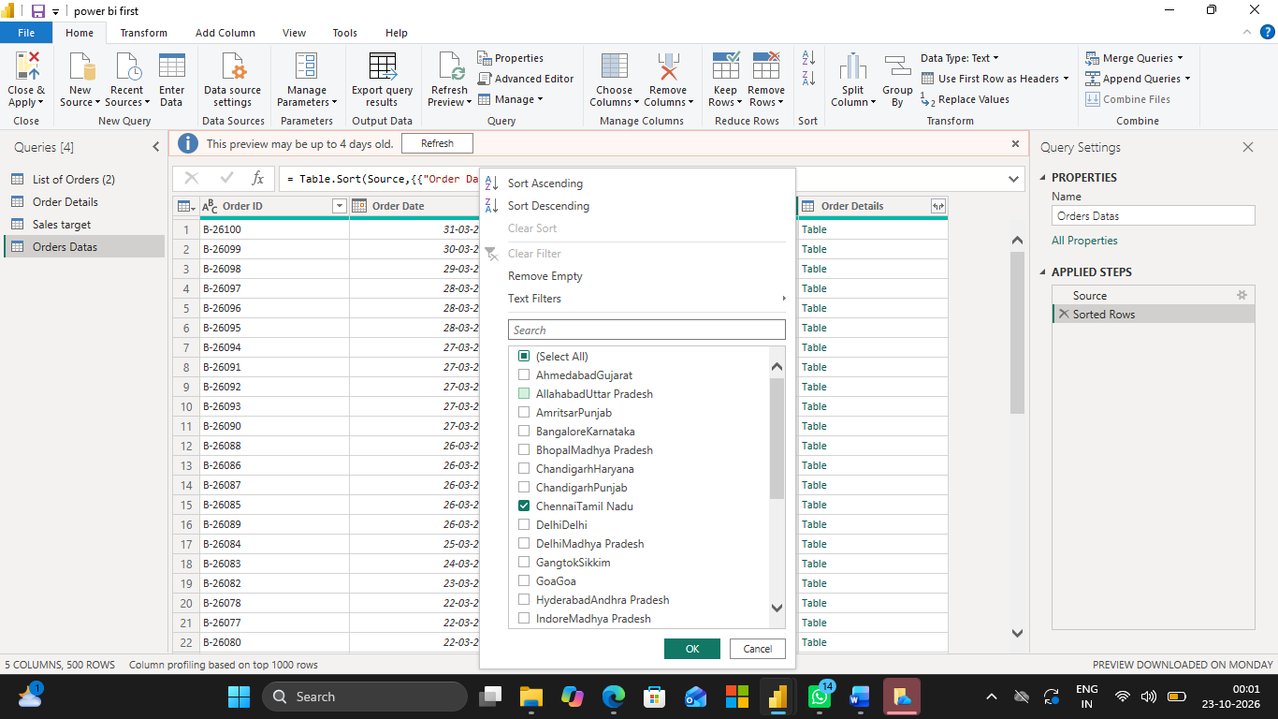

Final output:

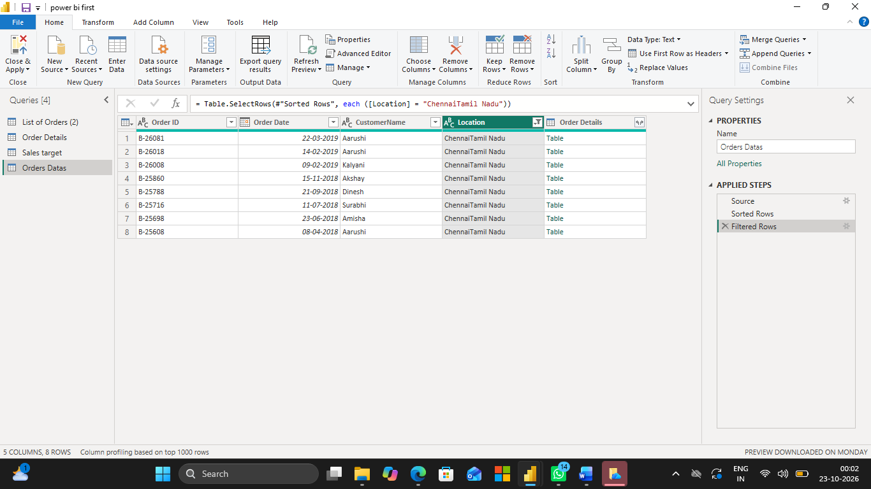

9. Grouping and Aggregating Data

● Duplicate the Order Details table and perform the following:

Duplicate the Order Details table
- Click Home → Transform Data.
- Right-click the Order Details table.
- Select Duplicate.

Count of Order ID
- Select the duplicated table Order details(2).
- Go to Home → Group By.
- Select Order ID in Group by.
- Enter the new column name: Count of Order ID.
- Select Count Rows under Operation.
- Click OK

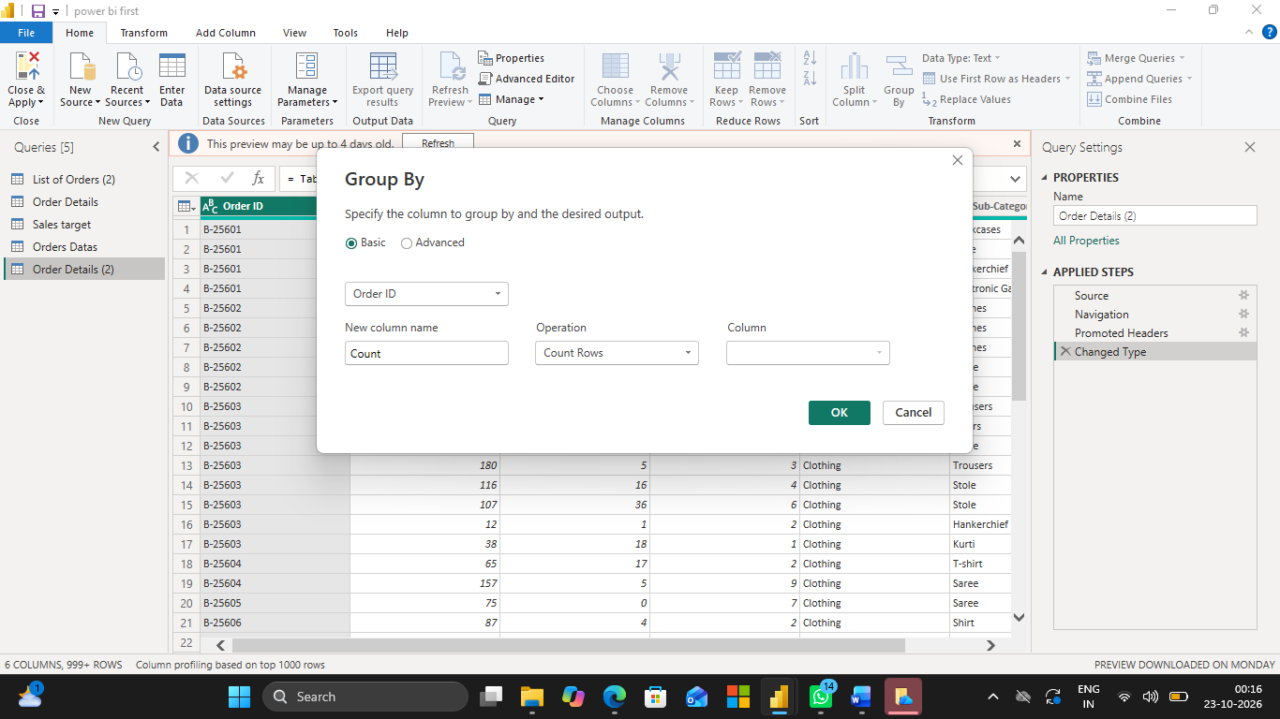

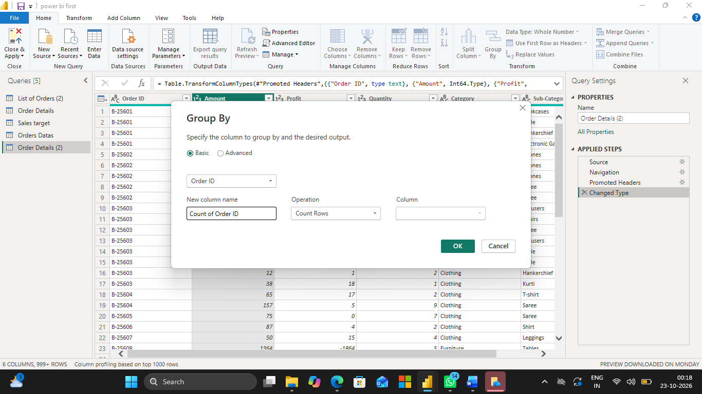

Final output:

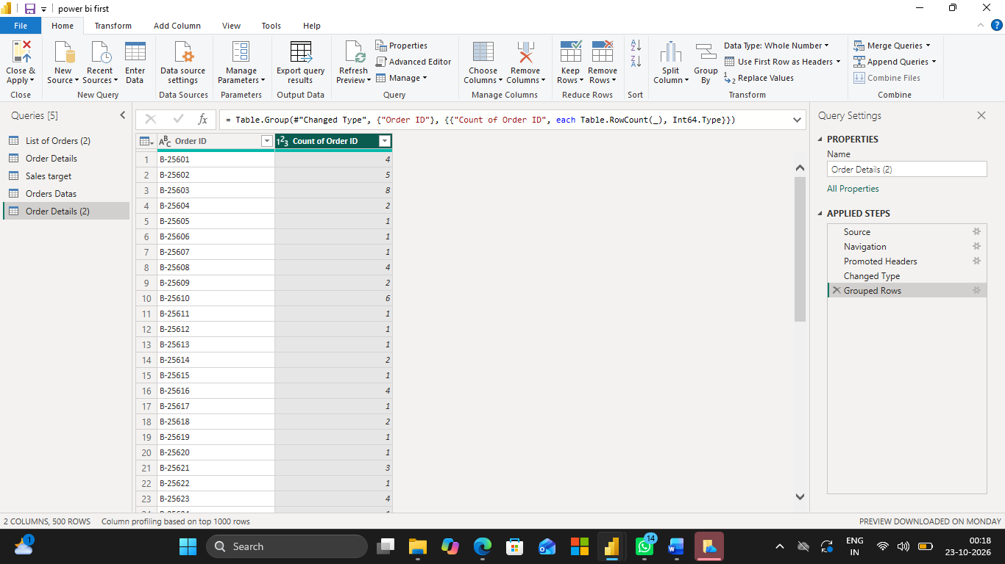

Average Profit by Category
- Right-click the original Order Details table and select Duplicate.
- Click Home → Group By.
- Select Category under Group by.
- New column name: Average Profit.
- Operation: Average.
- Column: Profit.
- Click OK.

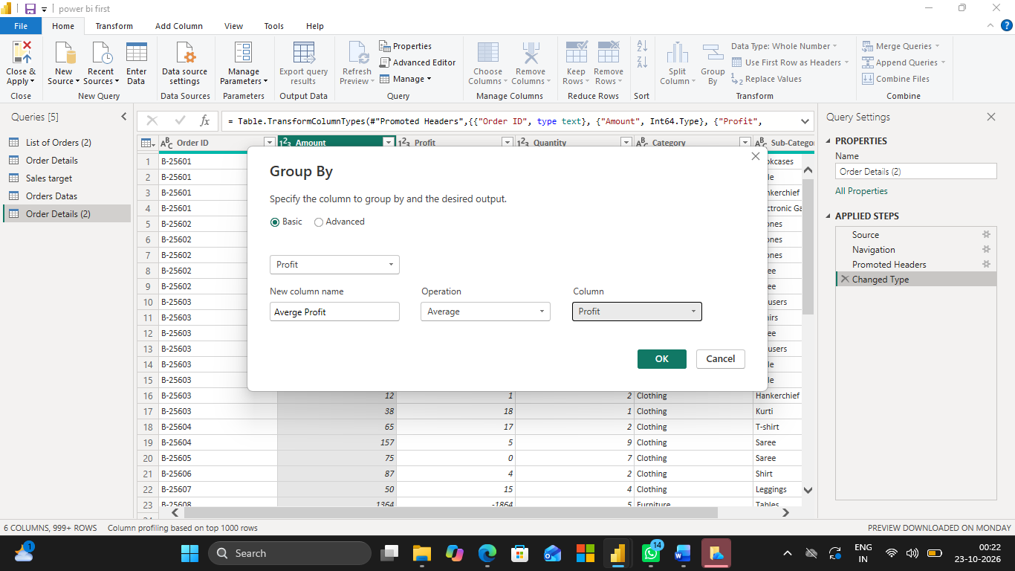

Final output:

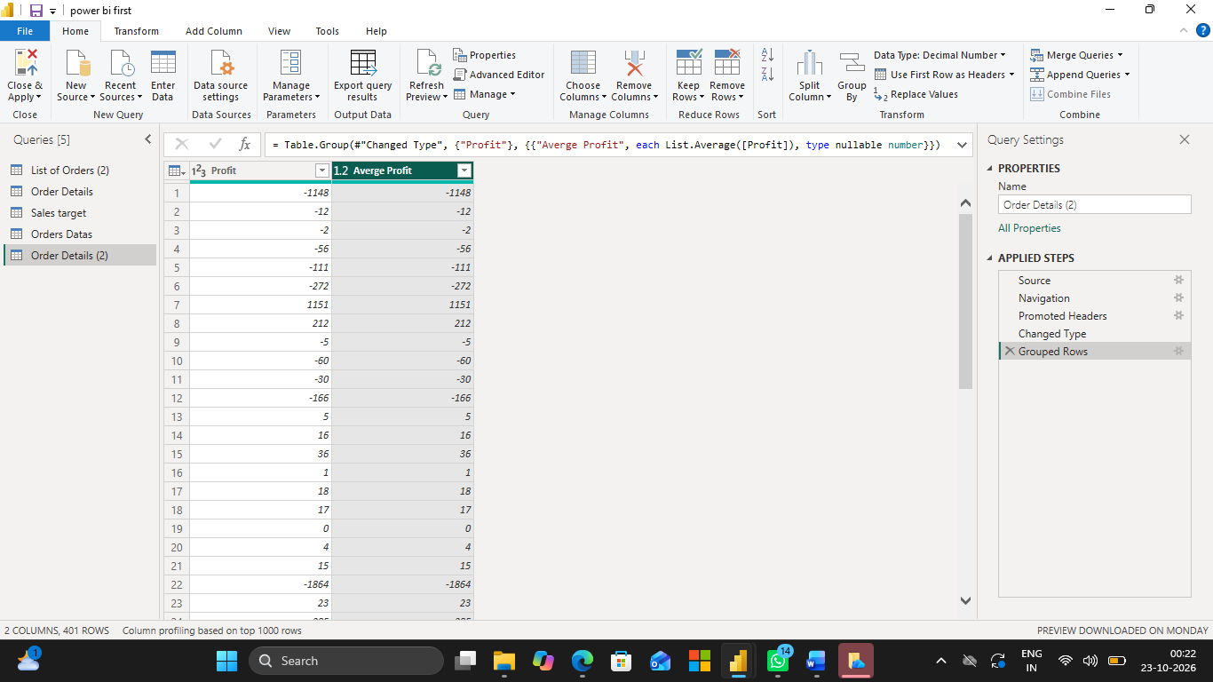

Total Amount by Sub-Category
- Duplicate the Order Details table again.
- Click Home → Group By.
- Select Sub-Category under Group by.
- New column name: Total Amount.
- Operation: Sum.
- Column: Amount.
- Click OK.

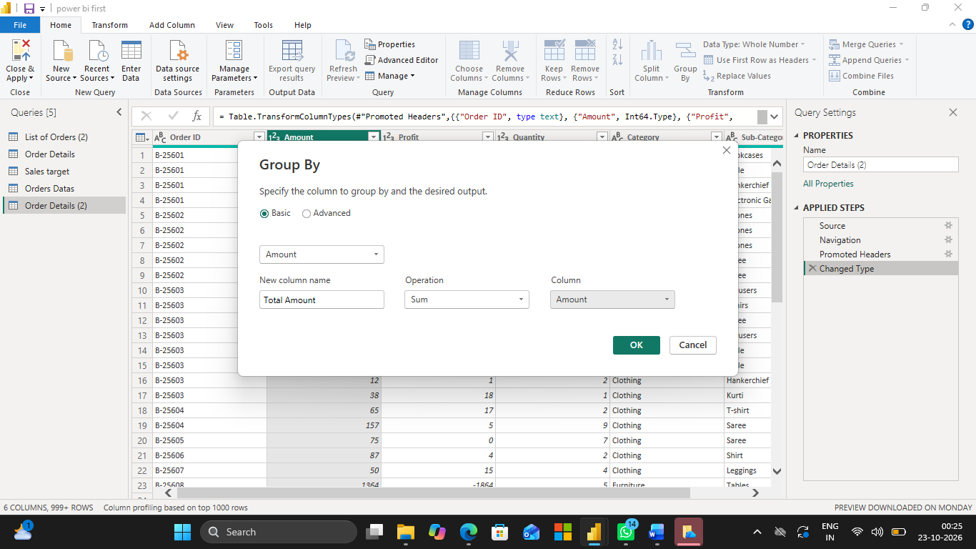

Final output:

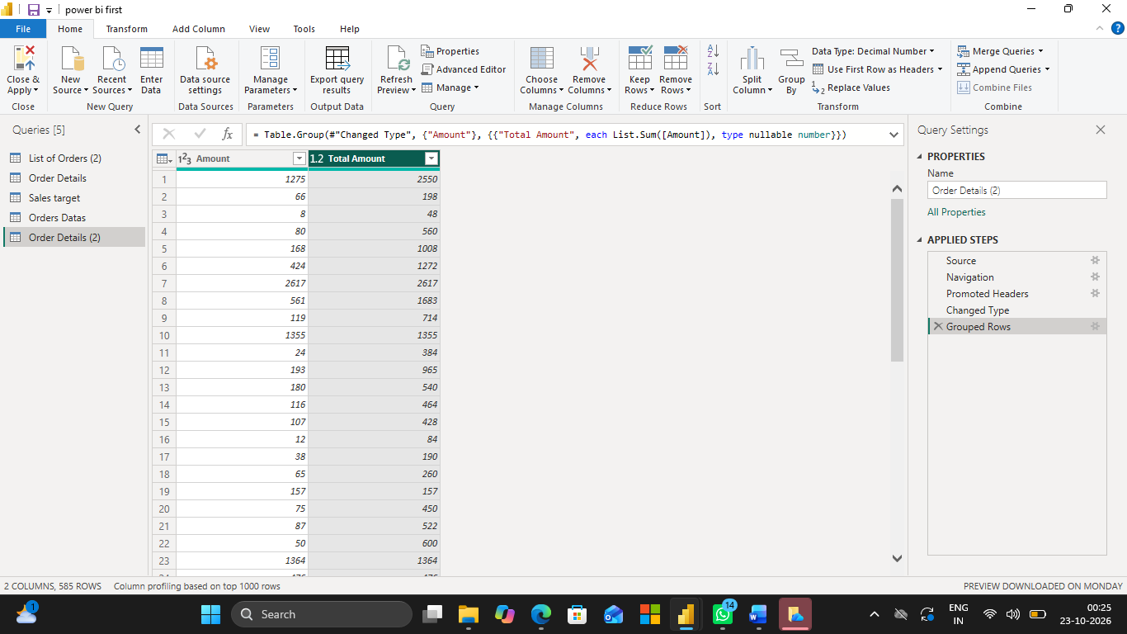

● Duplicate the Sales Target table and aggregate the total Target by Month of order date.

- Click the Sales Target table.
- Right-click and select Duplicate.
- To get the order month, merge the duplicated table with List of Orders using the Order Date relationship or an appropriate common key, if available.
- Extract the month from Order Date using Add Column → Date → Month → Name of Month.
- Click Home → Group By.
- Group by the month column.
- New column name: Total Target.
- Operation: Sum.
- Column: Target.
- Click OK

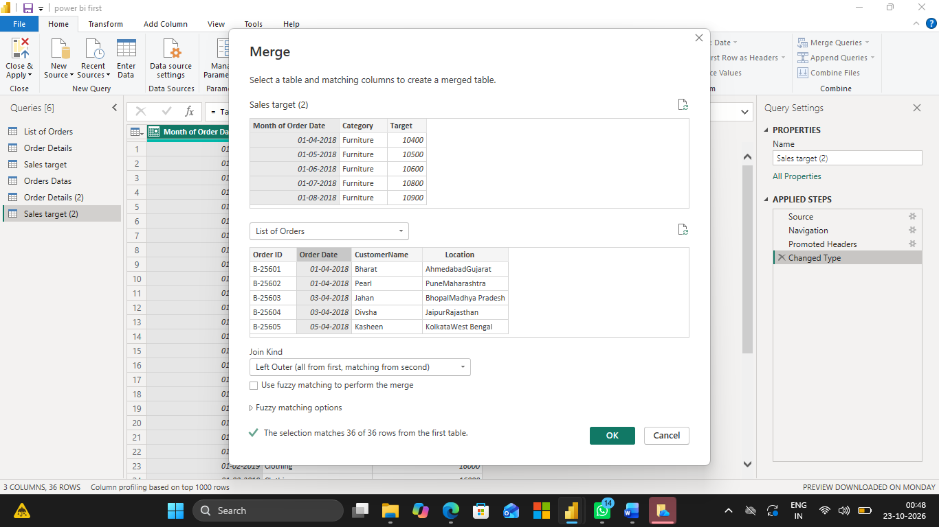

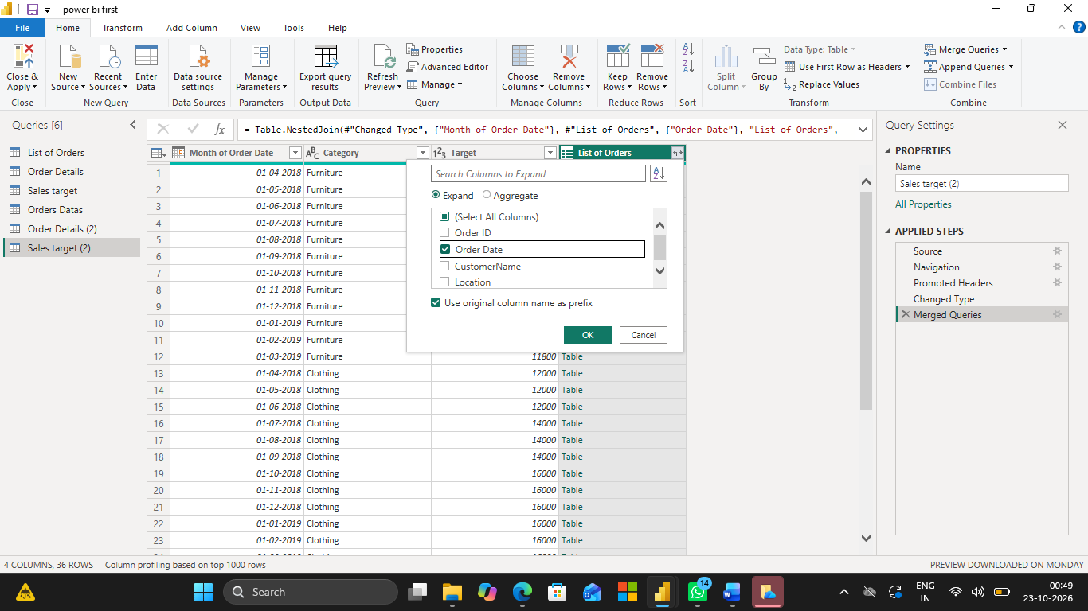

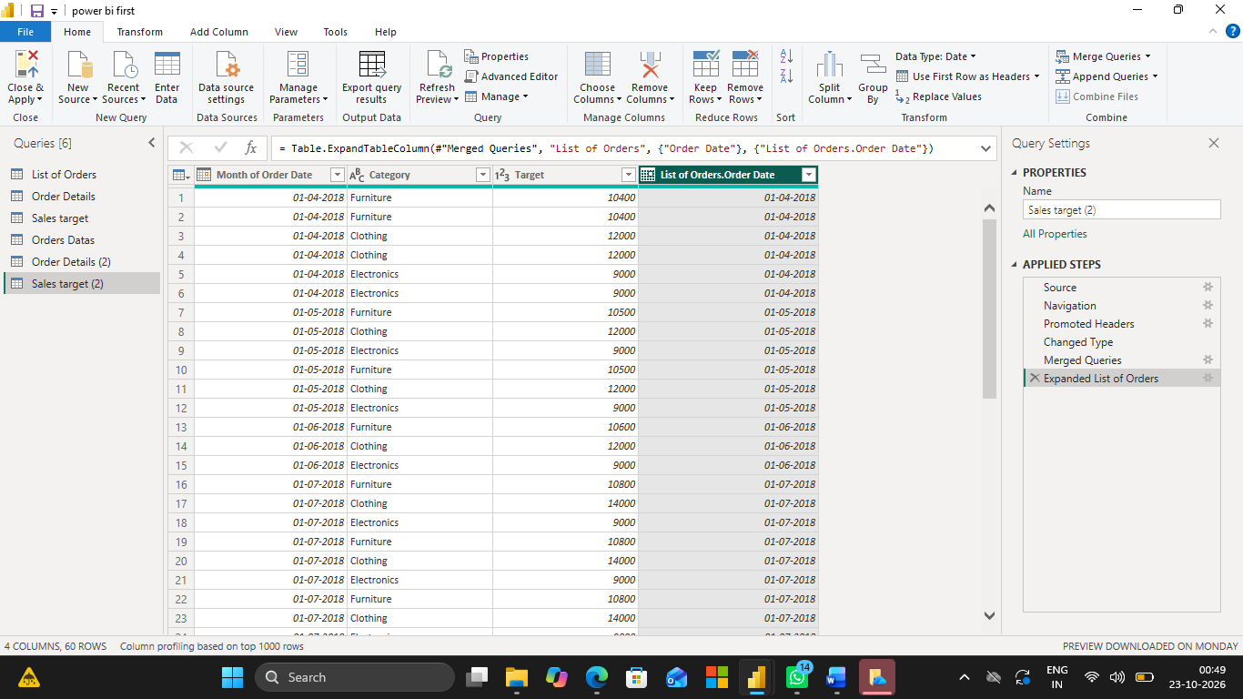

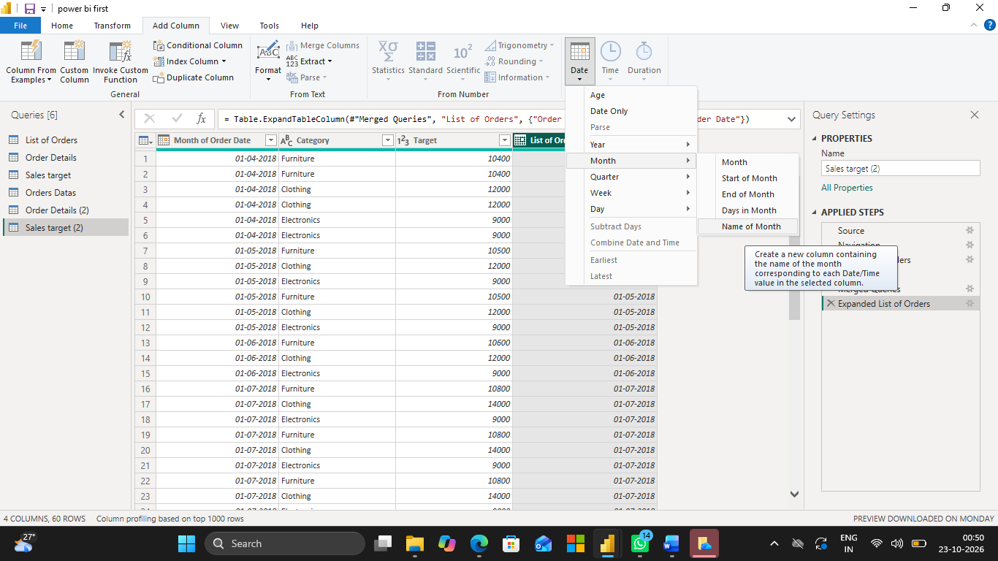

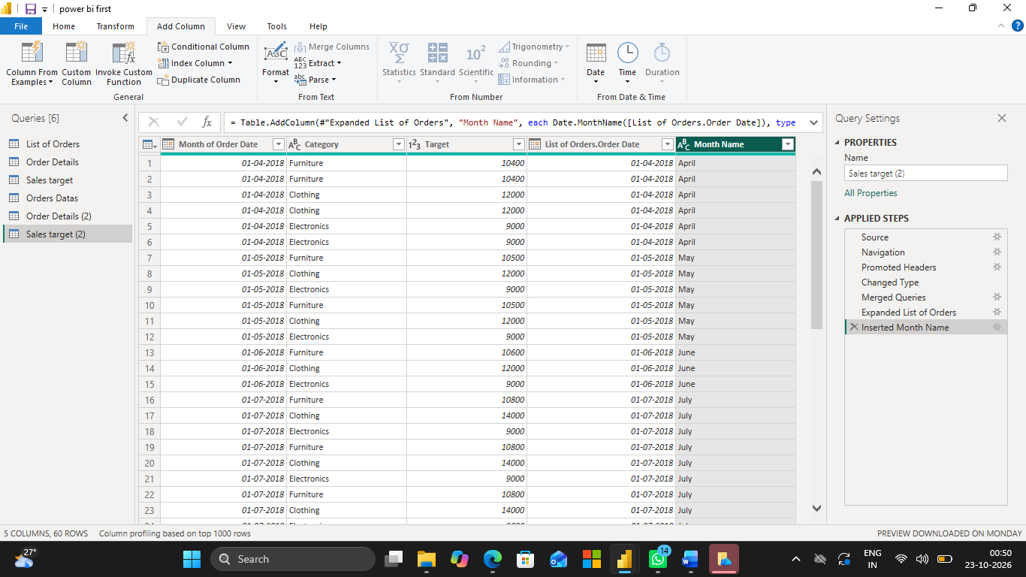

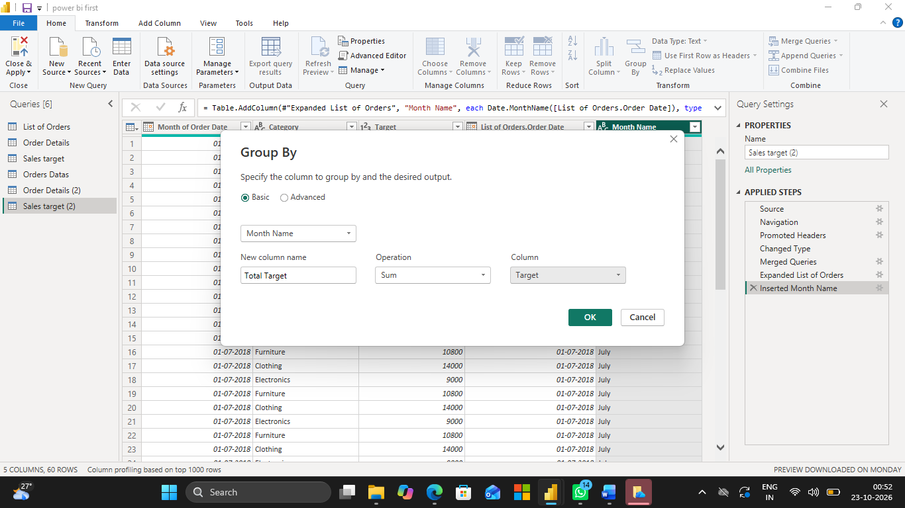

Final output:

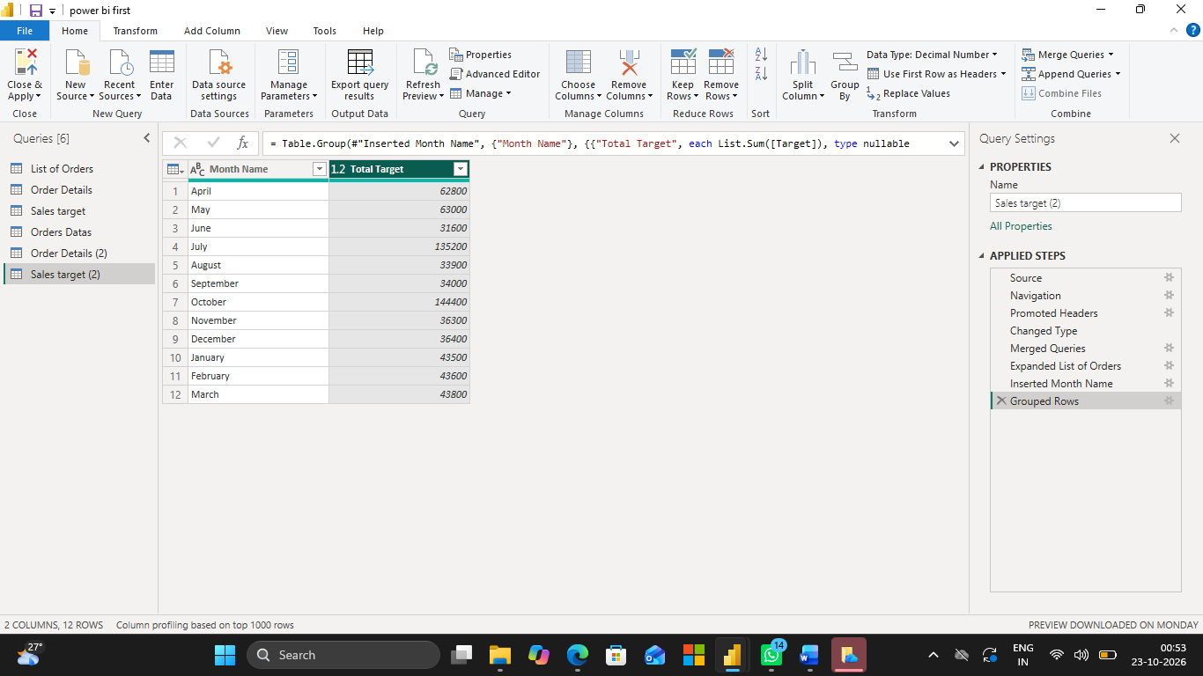

10. Data Modeling:

1. Establish a relationship between:

○ List of Orders and Order Details using Order ID

Create a relationship between List of Orders and Order Details
- Open Power BI Desktop.
- Click Model View on the left side.
- Go to Manage Relationships → New.
- Select the List of Orders table and the Order ID column.
- Select the Order Details table and the Order ID column.
- Set the relationship to One-to-Many (1:*), if Order ID is unique in List of Orders.
- Check Make this relationship active.
- Click OK.

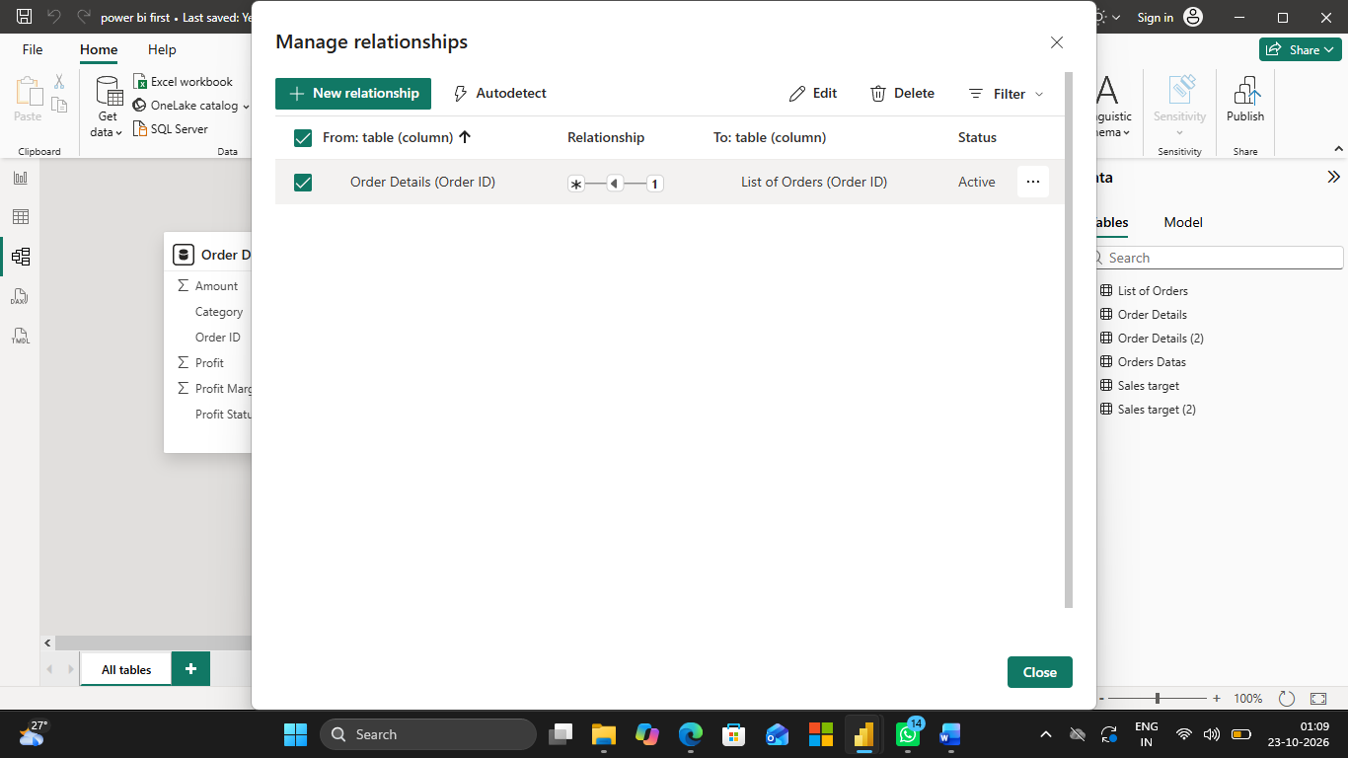

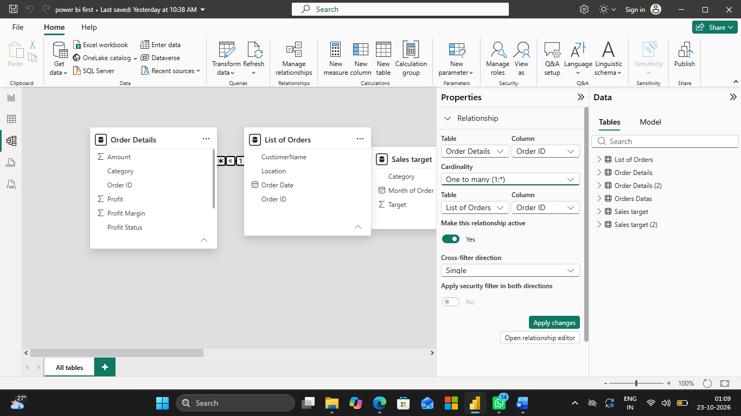

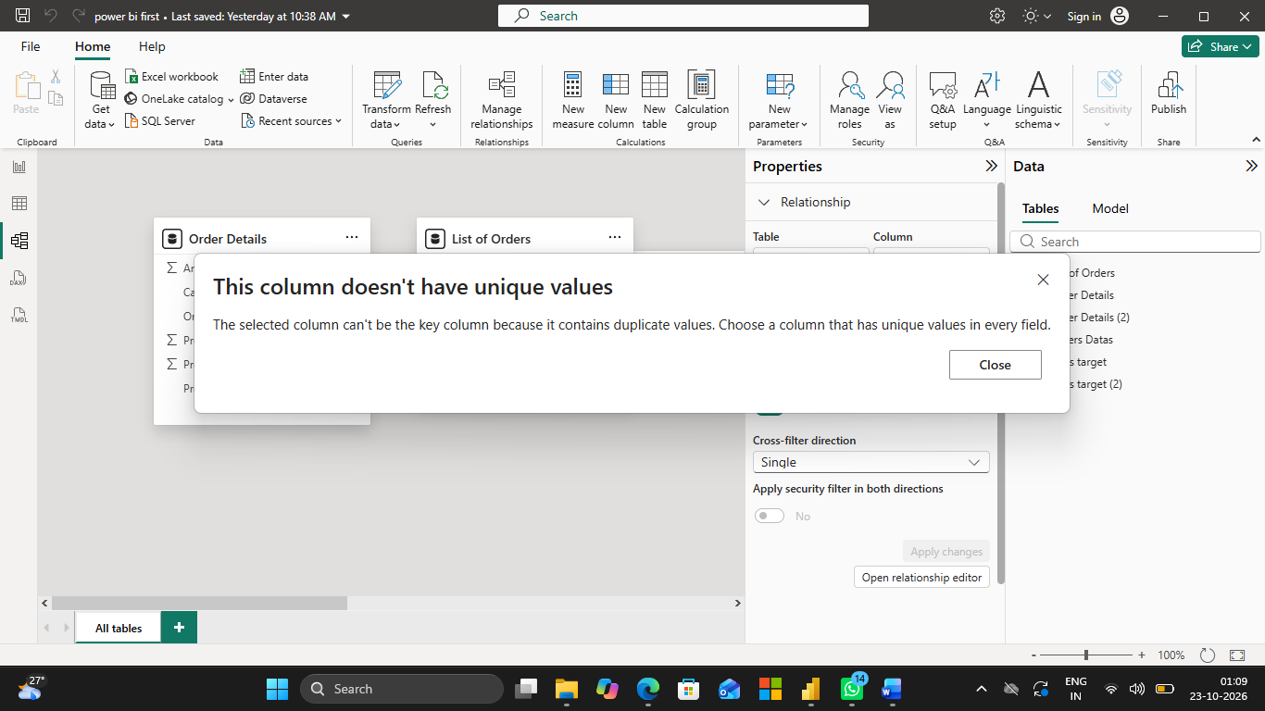

● Establish a relationship between:

○ Order Details and Sales Target using Category

Create a relationship between Order Details and Sales Target
- Go to Manage Relationships → New.
- Select the Order Details table and the Category column.
- Select the Sales Target table and the Category column.
- Choose the appropriate cardinality based on the data.
- Check Make this relationship active.
- Click OK.

2. Use Manage Relationships to ensure relationships are active and correctly defined.
- Open Manage Relationships.
- Check that both relationships are listed.
- Confirm that both relationships are active.
- Click Close.

